**1. Introduction**

This final year project will cover the research, design, verification and optimisation of 5 Tuple [1] extraction module for 10 gigabits/second (Gb/s) Ethernet [2] traffic and address the possibly to extend the design for 40 Gb/s communication. A 5 Tuple consists of a network layer source and destination address and the protocol field used to represent the transport layer protocol in use and also the transport layer source and destination ports. This information makes what is called a socket which is used to represent a link between two devices and can be used for traffic classification and normalisation to manage the connections and to correct anomalies in traffic.

The internet is made up of many different connections and interfaces which are standardised and follows the Open Systems Interconnection (OSI) Seven Layer Model [3]. Data traffic has a hierarchy of formats with a transport layer segment being emended to a network layer packet which in turn is encapsulated inside a data link layer frame. A segment, packet or frame consists of a header and payload with a frame also having an additional checksum that is used to detect any error that could have been produced in the traffic while the frame was in transit. The data link layer standards for Ethernet (IEEE 802) are a collection of standards that are some of the most widely implemented across the internet. The main Ethernet standard that is under inspection for this report is IEEE 802.3 [4] which covers the Ethernet standard for a method of communicating over copper and fibre optic mediums for a number of different speed that range from 2.94 Mb/s to 100 Gb/s. This standard specifies a frame format for the way data is to be represented across a Local Area Network (LAN) [5] and how to transmit and receive this frame format with extensions for different types of networks. This frame format can be altered as it is past between different connects which cause additional header information to be added which must be accounted for. Virtual Local Area Network (VLAN) [6] and Multi-Protocol Label Switching (MPLS) [7] are two widely used standards which alter the format of an Ethernet frame. The network layer Internet Protocol (IP) [8] (RFC 791) is the most widely used network layer protocol and therefore it will be assessed. This protocol specifies the header format for an IP packet and how the header field is to be set up for transmission and decoded when receiving data. The transport layer protocols that will be inspected for this report are the Internet Control Message Protocol (ICMP) [9] (RFC 792), Transmission Control Protocol (TCP) [10] (RFC 793) and User Defined Protocol (UDP) [11] (RFC 768) so as to understand there header format to correctly extra data for the 5 Tuple.

The internet is growing rapidly as over the past 42 years Ethernet data rate has increased by a large factor and there has also been movement towards extending the standards for 400 Gb/s and possibly a 1 Tb/s links. Speeds have increased from 2.94 Mb/s on copper coax in 1973 to 100 Gb/s on optical fibre in 2015. This shows that there is ever growing demand in devices to preform traffic classification and normalisation. These very high speeds cannot be handled with software as the overhead produced with a fetch-execute methodology waste a lot of time so therefore hardware solutions are used which are much faster. Hardware solutions can be implemented in a number of different ways such as using a Field Programmable Gate Array (FPGA) [12] or manufacturing an Application Specific Integrated Circuit (ASIC) [13]. The design for this report will be produced for a FPGA which must be coded in a certain fashion so as that each combinational logic block between registers completes its task before the next rising or falling each of a digital clock. To produce a design for a FPGA hardware description language must be use and this design will be written in VHDL hardware description language and will use ModelSim [14] simulation software to design and test the code.

The objective of this report is to investigate the possibility of a lightweight hardware design that can quickly extract the 5 Tuple of an incoming frame and to design, verify and optimise a 10 Gb/s project. The first main objective is to obtain all the relevant information required to fully understand how the design will be constraint and to determine the input and output of the design and their correct format. Next a hierarchical design must be produced, making use of the research, as well has individual submodule designs. These designs must then be implemented into code using VHDL. The code will then be verified when it is complete and debugged if any problems are found. Then the code will be optimised so as to make the design more cost effective.

The problems that will be solved in this report are how to correctly decode incoming data, remove the frame checksum after the end of frame has been detected, decoded the Ethernet frame header to correctly find the position where the payload starts in the incoming frame, extract the 5 Tuple from the IP header and transport layer header, output the 5 Tuple with the IP packet and detect different errors. The errors to be detected are traffic errors, Ethernet header errors, MPLS errors, IP length field errors and IP protocol field errors.

This final year project report is comprised of 5 main chapters. Chapter 2 provides background related information on Internet, communication protocols and summarises relevant literature. Chapter 3 explores a suitable system architecture and outlines in detailed the functional components of the proposed hardware-based 5 Tuple extraction circuit. Chapter 4 presents the design and verification of the circuit using VHDL. Chapter 5 explores the design and discuss various optimisation strategies for speed and area using Xilinx’s Vivado [15]. Finally Chapter 6 draws a number of conclusions and explores future work.

**1.1. Objectives**

1. To gather a better understanding of layers 1 to 4 of the OSI Model and were traffic classification and normalisation is performed.
2. To understand the interface between the physical layer (PHY) [9] and the data link layer in the Ethernet standard for a 10 Gb/s design.
3. To review how data can be encapsulated into an Ethernet frame and how it can be altered using different standards such as VLAN and MPLS.
4. To investigate how to extract the correct fields depending on where the payload of the Ethernet frame starts.
5. To understand where the 5 Tuple fields are positioned in the IP header and the different transport layer protocol headers.
6. To understand why traffic classification and normalisation must be done.
7. To determine a hierarchical design and submodule designs for a 10 Gb/s specification.
8. To code and verify the design so that it can be used on a FPGA using hardware description language VHDL and simulation tool ModelSim.
9. To optimise the VHDL code so that the best performance and circuit area is achieved using Vivado.
10. Potentially build the design on to a FPGA.

**1.2. Methodology**

1. To research and review documentation that will give understanding for a number of different protocols used on a number of different layers of the OSI Model.
2. Calculate clock rates and specify bus widths for 10G traffic interfacing from a PHY and define module I/O.
3. Define module hierarchy in terms of sub modules that will perform specific different tasks for different layers of the stack and a multiplexing structure.
4. Design each sub module with diagrammatic explanation and define specific required functionality.
5. Define what smaller generic modules will be needed such as test bench modules.
6. Code and debug each sub module separately starting with the generic modules as they will be built into the larger sub modules.
7. Optimise the VHDL code using synthesis Xilinx's Vivado for 10G traffic.
8. Potentially build the design on to a FPGA.

**2. Background**

**2.1 OSI Seven Layer Model**

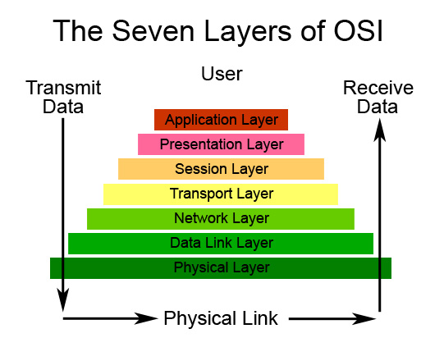

Figure 1: OSI Seven Layer Model [16]

Above is a diagram of the seven layer reference model. Each layer has a set functionality and there is also cross layer functionality such as security. The layers can be divided into two sub-groups. The upper four layers are grouped together as host layers and the lower three layers are the media layers.

As can be seen, to pass a piece of data from one device to another it must be first passed through the seven layers. If data is to be transmitted it must pass through each layer until it is passed on to the physical medium and at each layer a header is added and in some cases also a footer. These headers indicate to the receiving side the parameters that must be taken into account. For example in the IP header there is a field which indicate the header length which is used to indicate that IP options are used.

The physical (PHY) layer has a broad definition but simply put it is the layer that represents the physical medium and transmits and receives bit streams of data. The data link layer (referred to the Media Access Control (MAC) layer in the IEEE 802.3 standard) is the layer that is used for frame reliability functionality by performing a checksum calculation on ever frame sent and received and can be used to preform layer 2 addressing but this is usually done in the network layer. The network layer is used for routing across a network and is the main layer for controlling traffic. The transport layer is responsible for basic data transfer, reliability and multiplexing. The functionality of the transport layer varies depending on the protocol used as it can be extended to deal with flow control, precedence and security. The session layer deals with managing the communication as data is pasted back and forth. The presentation layer is used to present the data to the application layer so functionality like encryption and decryption are performed in this layer. Finally the application layer is responsible for Application Programming Interfaces (API) [17] which can be used to interface to a web browser.

For this report the main layers that will be under inspection will be the data link layer, network layer and the transport layer as there is not enough time to fully research and produce a physical layer design. The protocols used in these layers will not be implemented as it is only their header formats that are needed to be inspected and understood so as to correctly extract the 5 Tuple. The layers high than the transport layer are not relevant to inspect for the design but traffic classification and normalisation must be assessed. These functionalities are done in the session layer and therefore some research will be done into the session layer.

In addition to the data link layer functionality, VLAN and MPLS protocols can be implemented were VLAN is an extension to the MAC layer and MPLS is an additional header field before the payload of a Ethernet frame and is consider a layer 2.5 protocol. These protocols are essential for the understanding of this report as they determine where in the payload of the Ethernet frame the IP header will begin and after that is determine the next stage is simplified as the 5 Tuple will always be in the same position.

The interfaces between the physical layer and the data link layer will be expressed as the input to the design that is to be produced for this report. The interface between the transport and the session layer will be defined as the output of this module.

**2.2. Physical Layer and XGMII**

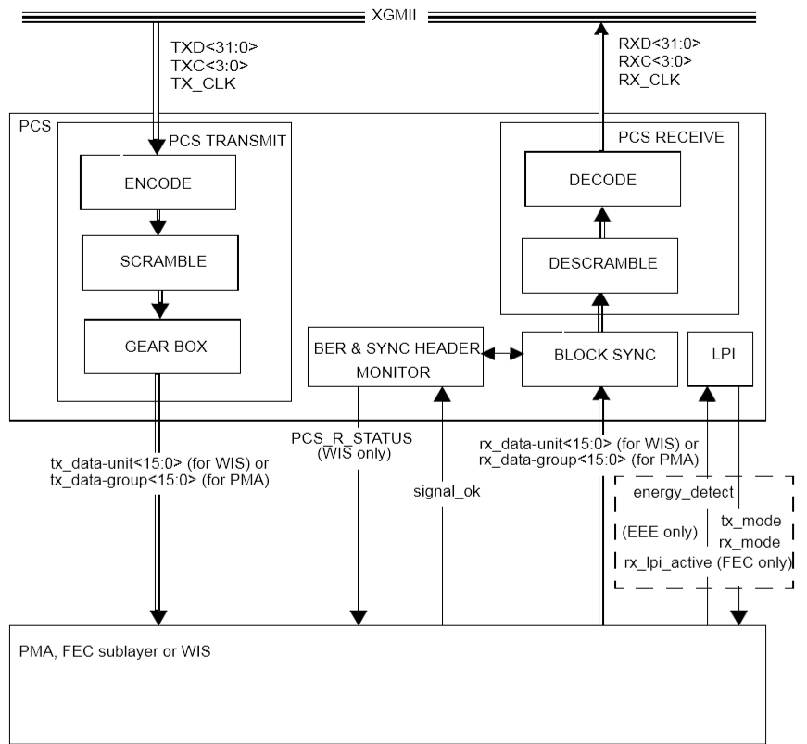

Figure 2: PHY and XGMII Interface [4]

The Physical layer of the ISO standard is used for many different functionalities such as data capture and alignment, 64b/66b block encoding [18] for 10G and upwards (8/10 bit encoding for 1G and lower) and scrambling the data so that it is DC biased [19] so that copper connections do not become saturated. Most of these functionalities are not important for the scope of this report but 64b/66b block encoding and how the PHY interfaces to the data link layer must be assessed. This interface is done using the 10 Gigabit Media Independent Interface (XGMII) [4] standard which can be implemented in a number of different ways and in reference with 64b/66b block encoding the format of data can be determined.

For 10G traffic the data width will be 32 bit wide with a 4 bit control vector to indicate the start and end of frame as well as to indicate if there has been an error with the received packet i.e. two start of frames after each other with no packet terminate between them. This interface will be how the data is input to the 5 Tuple extraction module. Sequence order sets can also be sent across the XGMII interface for local and remote fault and also for link interrupt.

The start of frame control word is 0xFB, the end of frame control word is 0xFD and the error control word is 0xFE. When a bit is set high in the control word it indicates that the byte corresponding to it holds the value of a control word. Where these control byte values can be positioned in the 64 bit word from the 64b/66b block encoding is essential so as to understand how the XGMII interface preforms data transfer. From inspecting the 64b/66b block encoding formats, stated in IEEE 802.3 and shown in Figure 3, it can be seen that the start of frame control byte can be in byte positions 0 and 4 and the end of frame and error control byte can be in any byte position of the 64 bit word. The possibility of have two start of frame positions means that the design for this report will have to deal with inspecting data depending on the start of frame offset. These 64 bit words are on a single data rate configuration but must be converted to a 32 bit double data rate (DDR) [20] formation. Double data rate can best be describe as data that changes on every event of the clock i.e. every rising and falling edge.

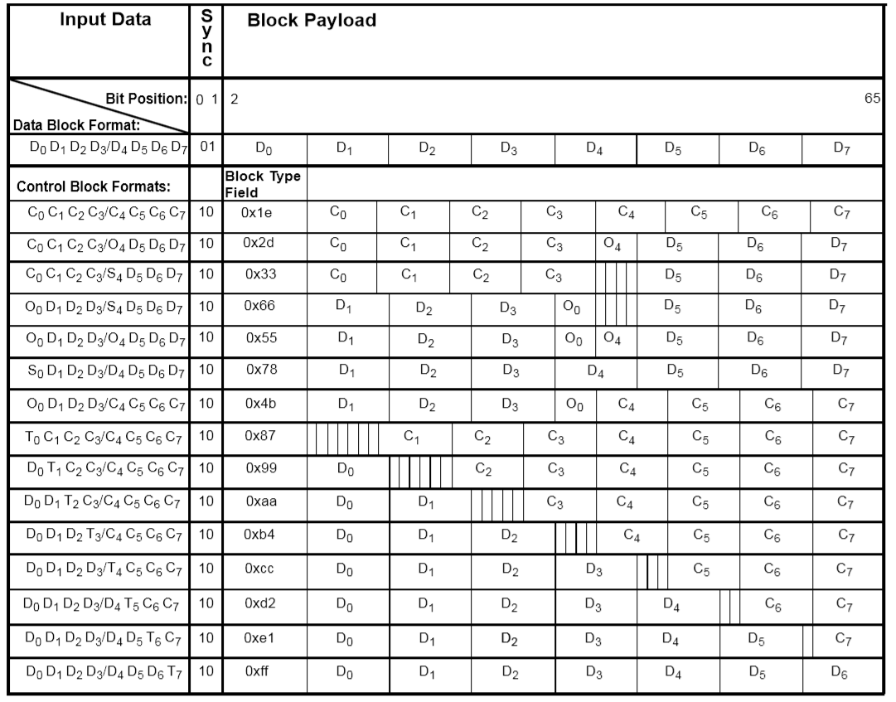

Figure 3: 64b/66b Block Encoding Formats [4]

**2.3. Ethernet Frame Structure**



Figure 4: Ethernet Frame Format [21]

For Ethernet a MAC layer is used to manage the access and transmission of multiple frames accessing a subnet as well as checking for errors using a cyclical redundancy check (CRC) [22] and the removal of the Ethernet frame overhead and Finite Checksum (FCS). For this design there will be no MAC layer implemented as there is no need for the functionality a MAC provides. The Ethernet frame format is important as it determines where the payload starts so that the correct header fields can be extracted. This frame structure can be altered when VLAN or MPLS is in use and these alterations must also be accounted for when extracting the 5 Tuple.

The length/type field, also known as Ether-type [23], is used to represent the network layer protocol that is being used in the payload of the Ethernet frame or the protocol used to alter the frame format. If the Ether-type indicates that the protocol encapsulated in the payload is IP then the packet will be simply passed on for header field extraction. If the frame uses VLAN, the type of VLAN has to be determined and when it is known the packet can be moved on to the next stage as soon as enough data has been stored to output a single 64 bit word. If the Ether-type shows that MPLS is employed then the number of labels must be determined and after this is known the packet is outputted when enough data is present after the last label. It is also possible that an Ethernet frame can employ both VLAN and MPLS at the same time.

**2.4. VLAN Tagging**



Figure 5: Ethernet Frame with VLAN Tags and Tag Structure [21]

VLAN tagging is when an extension to the Ethernet frame is added which must be accounted for when extracting the correct bit fields from the headers of the packet enclosed in the Ethernet frame. A VLAN tag is added to a frame so that a user connected to a VLAN can connect to the same VLAN remotely with ease and security in different locations using different routers. It is used by only letting VLAN tagged data through and this is done with the use of the VLAN ID.

The 32 bit VLAN tag structure is as shown in Figure 5 with the VLAN type field being used to define the Ether-type value so that VLAN can be decoded to be in use. This tag is placed between the source address and Ether-type field of the Ethernet frame format. The VLAN priority is a 3 bit field use to prioritise the different types of traffic in the payload of the frame for example a decimal value of 7 represents “network control” and a value of 2 indicates that an “excellent effort” will be given to the frame. The VLAN canonical format indicator, now called the drop eligible indicator, is used to show if the frame should be dropped in the case of congestion. This information is used for classifying the traffic. The VLAN ID is used to identify if the frame is eligible to be accepted at a destination.

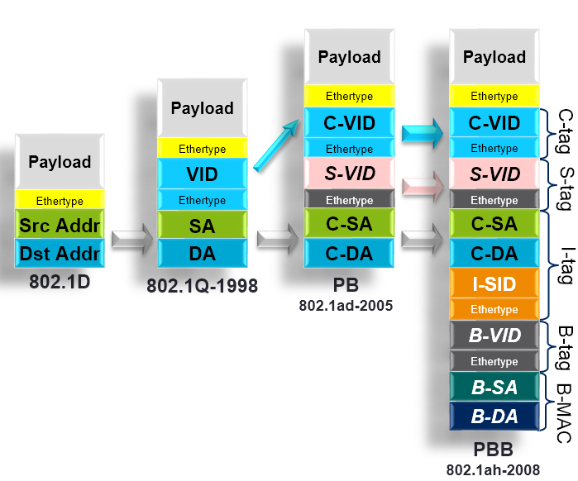

Figure 6: Different Types of VLAN Tagging [24]

Multiple VLAN tags can be added to the header in a number of different ways such a single tag known as a Q tag, a double tag known as Q in Q or provider bridging (PB) [24, 25], a triple tags stacked with the use of a user defined value which is known as Q in Q in Q and a quadruple tag known as MAC in MAC or provider backbone bridging (PBB) [24, 25]. The frame format for each of these methods is visible in Figure 6.

0x8100 is the default customer tag Ether-type value for a Q tagged frame. If a PB stack is implemented then the first tag after the source Ethernet address is set with the Ether-type field set to 0x88A8 for the service VLAN tag and 0x8100 for the customer VLAN tag. The service tag can also be set to 0x9200 and customer tag set to 0x9100 for PB stacked VLANs as these are the values stated for some older devices and must also be incorporated to deal with any compatibility issues. For triple VLAN tagged frames the first VLAN tag received could be a user defined value or 0x9300 as this is an older method of VLAN tagging [21]. For a PBB implementation there are 2 sets of Ethernet source and destination addresses, 2 sets of service tags and customer tags related to the 2 set of addresses as well as another Ether-type field to indicate if IP or MPLS is being used.

**2.5. Multi-Protocol Label Switching**



Figure 7: MAC Frame will MPLS headers [21]

MPLS is employed by the many internet providers as it is a standardised way of communicating many different traffic types with a reliable way of transmitting data and can be used in a multicast or unicast method which have Ether-type values of 0x8848 and 0x8847 respectively. If a packet comes across a MPLS switch on its journey to its destination or the host sender has implemented MPLS, the route will be determined before sending the data so that the additional MPLS labels are correctly stored at each node that the packet must pass through.

The label indicates the path of nodes in the route and is used in a look up table fashion when a frame is received at a node in the system. If a match is found in the table the label is removed and replaced with the corresponding value that is stored in the look up table. This is called a Forward Information Base (FIB) [26]. The labels added for this protocol are 32 bits which are inserted between the Ethernet and IP headers and there can be a number of labels stacked together to pass through multiple layers of a MPLS network. These additional labels will have to be accounted for when extracting the 5 Tuple of a packet. The CoS/EXP bits are an experimental field which can be defined by the service provider for quality or service much like VLAN. The time to line (TTL) is the value of the number of hops from node to node the frame must take before reaching the destination. The S bit indicates the last label in the stack and can therefore be used to find the number of labels amended to the frame so that the correct header fields can be easily extracted for the 5 Tuple. Juniper allow up to 5 MPLS labels to be added [27] but there can be up to 6 labels amended to every packet as this is how many is implemented by Cisco [28] at the time of this reports completion.

**2.6. Internet Protocol**



Figure 8: IP Header [29]

IP calls on local network protocols or look ups to carry the packet to the next gateway or destination host. These look ups are done at each note of the route to determine the next hop the packet will take. The IP protocol has 2 functionalities which are addressing and fragmentation. For the scope of this report fragmentation will not affect the functionality of the 5 Tuple extraction as the IP header will still be amended to each fragment. There is 2 IP protocols which are IP version 4 (IPv4) and 6 (IPv6) [30]. For this design only IPv4 will be considered as IPv6 is not yet as widely used and has a different header format.

The version field represents what IP version is being used and for this design it will be of default decimal value 4. The header length will indicate if there is options used and therefore will show where to extract the transport layer source and destination ports for the 5 Tuple. The TOS field is now known as the differentiated services (Diffserv) [31] which is split into two fields were the upper 6 bits are differentiated service code point (DSCP) and the lower 2 bits for explicit congestion notification (ECN). Total length states the total length of the IP packet. The indication is assigned by the sender to aid in reassembling fragments. The flags are used to indicate if the packet can be fragmented or if there is more fragments to follow the received packet. The fragment offset indicates where in the packet the fragment belongs which is measured in units of 8 octets (64 bits) with the first fragment with the offset of 0. The TTL indicates the number of hops the packet is to take before being destroyed. This is done to stop packets circulation the systems indefinitely. If the TTL is 0 and the destination address does not match the device IP address the packet is destroyed. The protocol field is to be extracted and should only except values for ICMP, TCP and UDP which have values 0x01, 0x06 and 0x11 respectively. The checksum only accounts for the IP header and is used to check for errors. The source and destination addresses are used by look up protocols such as the interior gateway protocol [32] and the exterior gateway protocol [33]. Where the protocol field and source and destination addresses are positioned is crucial to this design as they must be extracted for the 5 Tuple.

**2.7. Internet Control Message Protocol**



Figure 9: ICMP Header [29]

ICMP is used to report different errors or feedback about many different problems that can occur when trying to acquire a complete link. The type field indicates what problem has occurred and the code field elaborates even farther what has happened. As see in Figure 9 there is an extensive list of types and codes to help set up and correct a link. This protocol does not use source and destination ports and therefore a full 5 Tuple cannot be extracted. In the case of ICMP only the source and destination addresses and the protocol field will be placed into the output 5 Tuple.

**2.8. Transport Control Protocol**



Figure 10: TCP Header [29]

The source and destination ports are the first 32 bits making it very easy to extract them for the 5 Tuple. The sequence number is used to order the received data. The acknowledgement number is set to the next segment expected by the receiver so as to keep that data in order and the TCP flag must be set for an acknowledgement i.e. flag field set to 0x10. The offset indicates the number of 32 bit words that are prior to the data. The C flag is set to acknowledgement that the last packet received had the E flag set. The E flag indicates that explicit congestion notification can be used with the paired socket when the SYN flag is high and if it is low this indicates that in the IP header the congestion experienced flag is set high. If the U flag is set this means the urgent pointer field is to be used. The A flag is set due to an acknowledgement being sent. The P flag is set for push functionality. The R flag is set to reset the connection. The S flag is set to establish a connection and the F flag is set to brake a connection. The window is an indication of how many octets the receiver can handle. The checksum is used to check errors in the header. The urgent pointer is used for the positive offset from the sequence number in the segment received. Options allow a maximum segment size to be set which is sent when trying to establish a connection.

TCP is used for many different functionalities which are connections, basic data transfer, reliability, flow control, multiplexing and precedence and security. Basic data transfer handles the segmenting and packaging of data to be sent from the application layer which can be send in a continuous manner in each direction. After the transmission is complete the link is broken to free up ports for other processes.

To establish a connection handshaking [34] must be done first which will obtain the socket information at both sides of the link. The handshaking entails a SYN being sent to a server which in turn sends back a SYN+ACK. Then the client sends back an ACK and the connection is established and data can then be sent freely. This handshaking can best be explained by Figure 11 which shows the three stages.

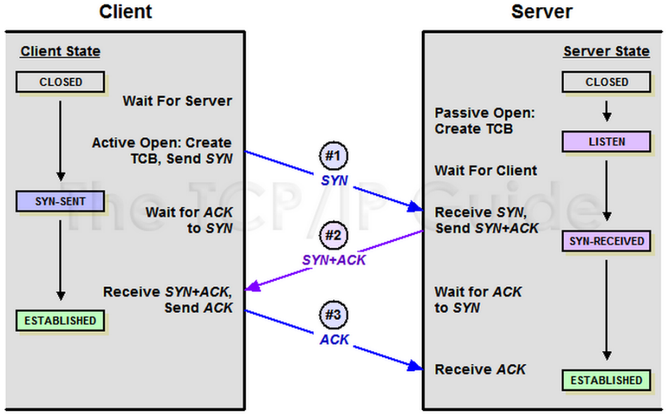

Figure 11: TCP Three Way Handshake [34]

The reliability aspect of TCP recovers data that is damaged, lost, duplicated or delivered out of order than which it is transmitting to the receiver. This is done by assigning a sequence number to each octet that is sent and requires a positive acknowledgement from the receiving TCP layer. If the acknowledgement isn’t received back at the sender in a given timeout interval the octet is retransmitted. At the receiving side of the link the octets are reassembled using the sequence number stated in the header. The receiver can control the flow of data sent by the transmitter by setting a window in the header. This window indicates a range of acceptable sequence numbers beyond the last segment successfully received that the sender can transmit before the receiver sends permission to send more.

TCP multiplexing is when ports are links to multiple processes for a single host. This is the concatenation of the IP and TCP address to form a socket and a pair of sockets makes a connection which is why the 5 Tuple is needed so as to check that a specific socket is formed. A TCP user can indicate the security and precedence of the connection but provision is made for default values to be used when there features are not needed.

**2.9. User Defined Protocol**



Figure 12: UDP Header [29]

UDP has same position as TCP for the source and destination ports as they are in the first 32 bits making it easy to extract the data for the 5 Tuple. The length field indicates the total length of the header and data encapsulated. The checksum is used to check the header and the data for errors that occurred with in transit.

**2.10. Traffic Classification**

A classifier is a device which inspects internet traffic so as to prioritise it depending on a chosen methodology. These devices can be used at the edge of a provider network and internally to prioritise the traffic flows. A traffic flow is established using handshaking and therefore can be associated with a socket that represents the source and destination IP addresses and transport layer port numbers. This socket, as well as the IP protocol field, makes up the 5 Tuple which can be used to classify traffic. Traffic is usually prioritised by grouping different types of traffic together depending on the necessity of reliability.

There are three main groups which are in the priority order of sensitive or assured, best-effort and undesired traffic. Sensitive or assured traffic is time sensitive flows such as online gaming and Voice over IP (VoIP) [35] which required data to be transferred instantly. Best-effort traffic can be best described as peer- to-peer traffic such as email. Undesired traffic is used to describe unwanted and malicious data transfers such as spam mail or denial of service (DoS) [36] attacks.

There are many methodologies of classification such as two stated in the document Architecture for Differentiated Services [37] (RFC 2475) defined by IETF which are Behavioural Aggregate (BA) and Multi-Field (MF) classification. There is also a statistical methodology which has been implemented in many different ways as well as deep packet inspection which attempts to inspect the payload of a segment. Statistical and deep packet inspection classification are outside the scope of this report and therefore will not be researched.

BA classification is performed by inspecting the Differential Service codepoint (DSCP) of multiple packets as they pass through the classifier, determining the aggregate of different flows and prioritising the flows depending on this collection of aggregates. This is called Per-Hop Behaviour (PHB) [37] forwarding and is performed by storing the packets for different flows and outputting them in a prioritised order. The DSCP can be found in the IPv4 TOS field as the TOS octet is replaced with a Diffserv field which is in the format of Figure 13 but still remains functional for use with IP precedence for quality of service (QoS) [38]. This is the computationally easiest way to classify traffic but has a very narrow scope of inspection as the Diffserv field is usually set by the transmitter and can also be altered while in transit. For this reason MF classification can be implemented to broaden the scope of inspection but there is a handoff as MF classification is much harder computationally. Due to the ease of computation BA classification it is mostly used internally to a network and not on the borders.

|  |  |  |  |  |  |  |  |  |
| --- | --- | --- | --- | --- | --- | --- | --- | --- |
| ***Bit*** | 0 | 1 | 2 | 3 | 4 | 5 | 6 | 7 |
| ***TOS*** | Precedence | | | Delay | Throughput | Reliability | Cost | 0 |
| ***Diffserv*** | DSCP | | | | | | ECN | |

Figure 13: TOS and Diffserv Field

MF classification is the type of classification that would be performed using a 5 Tuple but can also take into account many other fields set in the network and transport layer headers. MF classification is used when BA classification is insufficient. This type of classification can be used to encode a Diffserv into the IP header by inspecting different fields and determining a DSCP and is one of the possible ways of altering the Diffserv field while a packet is in transit. MF classifiers are used on the border of networks so as to classify everything as it passes in and out of ever network. These types of classifiers can be very useful as they can be used to establish a firewall [39] by only allowing specified packets through with the correct 5 Tuple.

Classifiers are used in conjunction with a traffic conditioner which can be used to store flow data and output them in a prioritised order depending on the methodology used which is called shaping the traffic. Packets can be dropped depending on their priority and the amount of congestion the system is experiencing which is called policing the traffic.

**2.11. Traffic Normalisation**

Normalisation of traffic is done as there is an increasing number of threats that can be masked by un-normalised traffic. Un-normalised traffic can be best explained as traffic that does not conform to regular standards. A normaliser device can be used to drop or correct packet depending on the normalisation criteria.

An example of traffic normalisation is when 2 packets are sent with the same 5 Tuple but different time to live (TTL) fields with one of the packets indicating a lower limit. The packet with the smaller TTL can be used to mask the packet with the higher TTL and as the two packets reach their destination the packet with the smaller TTL will be dropped by the system possibly 1 hop away from the destination and the masked packet, which could contain malicious functionality, is passed to the destination. Normalisation would remove this problem by introducing a network intrusion detection systems (NIDS) [40] to a gateway which would continuously monitor the traffic to detect ambiguities and then relay these ambiguities to a NIDS controller which would then be able to decipher the problem stated above and remove the packets from the system therefore safe-guarding the next gateway from harm. This is only one example of how traffic can be normalised but there are many forms of traffic normalisation.

Another example of how traffic can be normalised is by inspecting the header fields of incoming packets to check if they conform to the standards that are stated to be used. If they do not meet the standards the packet headers can be altered to meet the standard or be dropped if malicious intent is speculated. A set of constraints could be used here so as to only let known traffic through by inspecting the 5 Tuple. A normalisation device could take the 5 Tuple and the corresponding packet and preform flow classification and packet header normalisation by splitting both functionality and running them in parallel. The design to be produced for this report could incorporated some normalisation checks while the 5 Tuple is being extracted which could reduce computation after the 5 Tuple and packet are outputted but is unnecessary for the scope of this report.

**2.12 Hardware Design Process**

The hardware design process has a number of different stages. The first stage is a feasibility study which is done by doing research to see if it is possible to produce the desired design. This includes background research, finding the correct data width and clock frequency to provide the asked for data rate, defined the I/O of the module and finding a hardware solutions that will work i.e. specifying a FPGA make and model.

After it is determined feasible the design process can start. For this process a hierarchical diagram should be produced to fully understand how the design must be put together as well as individual submodule designs. This helps reduce erros when coding as many problems that could arise will be found and dealt with. For this stage, FSM diagrams must be produced to fully grip the functionality required of the sub modules.

When the design is fully finished the coding and verification stage can start. For this stage the design will be taken and implemented in a hardware description language such as VHDL or Verilog. The methodology most commonly used would be to code and verify the sub modules which appear first in the data flow so as to build the design as the sub modules are completed making the final assembly much simpler.

Once the design is coded and verified to work with the desired functionality it is optimised. This includes passing the design through a synthesis tool, such as Vivado, to determine if there is any critical paths or area problems. A critical path is the path between two register that has too much combinational computation to complete between them so that the data is not set up for the next clock cycle. An area problem would be that the design takes up too many registers or logical blocks on a FPGA or ASIC so it must be reduced.

After the design is optimised real world testing can be done by building the design on to a FPGA and inputting stimulus to verify that the correct functionality is achieved. This is a secondary stage of testing to clarify that after the design is built there are no ambiguous behaviours of the physical design.

After this the design is finished and full documentation can be completed for the release of the design.

**2.13 Ethernet Header Formats**



Figure 14: Ethernet Header Formats

In Figure 14 the different formats of the Ethernet header are shown starting with the basic IP Ether-type configuration which is followed by the different types of VLAN and different number of MPLS labels amended. The bytes 0 to 19 are always the same format so are not shown. “AA” indicates the first preamble byte and “SA” specifies the last byte of the Ethernet source address. This information is critical to the design as the longest possible header length is needed to be known so as to correctly size parts of the design.

There is no reason that MPLS could be employed inside a VLAN tagged frame so therefore the maximum header size that this report will have to deal with is the largest VLAN type, which is MAC in MAC, with the longest possible combination of MPLS labels amended between the Ethernet header and the payload of the frame.

If the frame uses VLAN type MAC in MAC then the payload starts on byte 50 and if six MPLS labels are also in use at 4 bytes a label then the payload will start on byte 74. This makes up a total of 592 bit for the maximum header therefore the Ethernet header store register will have to be 640 bits to deal with this size as each 64 bit word has to be stored and 592 is not a multiple of 64.

**2.14 Endianness**

Endianness is a term used to describe the order in which data is stored in a computer or transmitted on a line. Big Endian is specified as the first piece of information is stored in the most significate position and Little Endian is quantified as the first piece of information is stored in the lease significate position.

For this design the data traffic will be in a Big Endian format and for an example of this the preamble of the Ethernet frame must appear first in a 63 down to 0 vector with the start of frame delimiter either in the 4th or 0th byte position.

**3. System Architecture**

This section of the report will cover the design of the 5 Tuple extraction circuit which will take a top down methodology. The top level design will be first examined to fully understand what sub modules will be needed to be coded for the design. Then the generic sub modules that will be reused will be addressed as these will be of low complexity. Then the different state machines will be under investigation to fully understand how to decode XGMII traffic, remove the Ethernet frame FCS, decode numerous Ether-types and extract the IP packet depending on what is decoded, decipher the IP header and extract the 5 Tuple. These state machines will also have to detect a number of different errors and reinitialise themselves if detected.

Each state machine will have a state diagram to explain the states and the transactions between them with an extensive explanation to fully understand all the functionality required for the state machines to have. All modules will have a basic I/O block diagram to show the interfaces that will be connected through the design.

**3.1. Hierarchical Design**

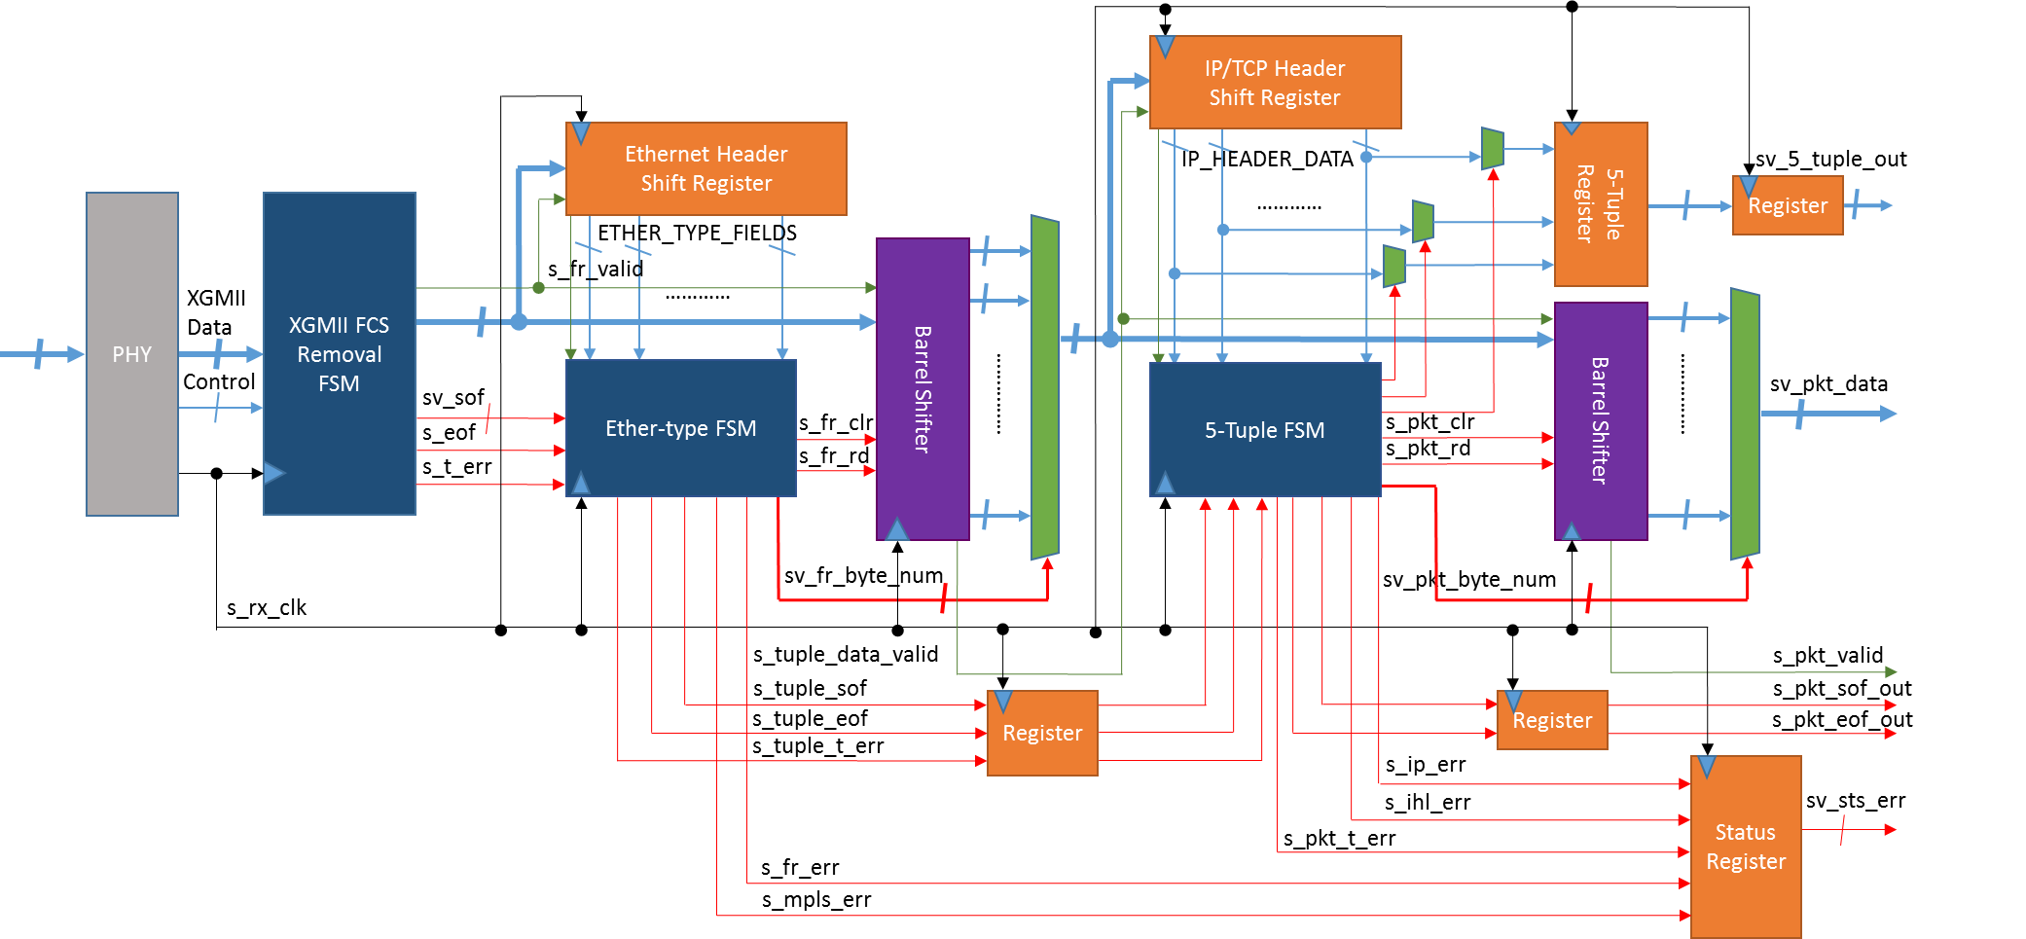

Figure 15: Hierarchical Diagram

This circuit is to take in data traffic and extract the 5 Tuple and then output the 5 Tuple with the IP packet. Figure 15 shows the hierarchical diagram of the proposed 5 Tuple extraction module and shows the sub modules required and how they must be connected. The data flow is denoted by the blue arrows with the valid in green and the control signals in red. There is added register stages in the top level to deal with the read delay from the Barrel Shifter modules. The clock for this design will be retrieved from the XGMII bus which is defined in section 3.1.1. The register reset is not shown in Figure 15 but will be implemented so as D flip flops [41] will be used in the synthesis. Most digital designs make use of status and control registers, for this design the status register can be seen but the control register cannot. The control register will be used as an input to the module and it will be used to set the user define VLAN tag value.

The input to this design will be data traffic past to it via the XGMII interface which includes four 8 bit data lanes and a 4 bit control vector. The control vector indicates if there is a XGMII control byte in one of the data lanes and therefore is used to decode the data being passed in. the outputs from this design will be the 5 Tuple, IP packet with start of frame, end of frame and data valid and the status register which indicates if an error has occurred in the traffic. These I/O are defined in section 3.1.2.

The XGMII FCS Removal FSM module is split into two separate Finite State Machines (FSM) with the first to be used to decode the XGMII bus to determine the start of frame and end of frame and detect if an error has been passed up by the PHY and the second to be used to remove the FCS. These FSMs will be labelled XGMII for the first FCS removal for the second FSM. The error is used to indicate to the next stage of a system that there has been a receive traffic error. The XGMII FSM will only be a simplified version of what is normally required as extra functionality of sequence order sets will not be needed.

The Ether-type FSM will be used in parallel with the Ethernet header shift register to inspect the Ether-type fields so as to deduce where in the incoming data to start extracting the payload of the Ethernet frame which will contain the IP packet. This module will output a byte count and a read enable to a Barrel Shifter module to extract the packet as well as a clear signal to flush the barrel after an error is detected and at the end of a frame that is not in error. There is a possibility of have two start of frame positions which means that the Ether-type FSM for this report will have to deal with inspecting data depending on the start of frame offset. This offset is due to the conversion of the data format from the XGMII 32 bit double data rate to the interior 64 bit single data rate. This module will also produce a start of frame and end of frame to be passed on to the 5 Tuple FSM as well as flag Ether-type and MPLS errors.

The Barrel Shifter will be a standard module that has a 64 bit input and output. This module outputs data stored in the barrel depending on the input byte number which determined the first byte of the 64 bits to be extracted and the read enable. As stated before the clear flushed the barrel of all data. This module has a read delay of one clock cycle which must be accounted for as the start of frame and end of frame flags will be out of synchronisation.

The 5 Tuple extraction FSM will perform the extraction of the multiple fields in the network layer and transport layer headers that must be concatenated together to form the 5 Tuple. It will also output the start of frame and end of frame flags as well as IP Header Length field and IP header protocol field errors. The errors to be detected are explained in section 3.1.3.

**3.1.1. Clock Rate Calculations**

The table below indicates the widths the data bus can take and the clock rate required to maintain total 10G and 40G data rate to calculate the clock rate required the following equation is used:

*Fc = Data Rate ÷ Data Width*

With a clock frequency of 625 MHz, using a data width of 64 bits for a 40G design is unrealistic so if this proposal is to be considered the 10G modules would have to be redesigned to work at a 256 data width.

|  |  |  |
| --- | --- | --- |
| ***Data Rate*** | ***Data Width*** | ***Clock Rate (MHz)*** |
| 10×109 | 64 | 156.25 |
| 40×109 | 256 | 156.25 |
| 40×109 | 64 | 625 |

Table 1: Clock Rates and Data Widths

**3.1.2. Top Level I/O**

This section defines the I/O of the 5 Tuple extraction module. The I/O is defined in Table 2.

|  |  |  |  |
| --- | --- | --- | --- |
| ***Input*** | ***Description*** | ***Output*** | ***Description*** |
| i_clk | Width = 1; input clock used for the whole design | ov_five_tuple | Width = 104; output 5 Tuple |
| i_rst | Width = 1; input reset to registers | o_valid | Width = 1; output data valid |
| i_valid | Width = 1; input data valid | ov_data | Width = 64; output packet data |
| iv_cntrl | Width = 4; input XGMII control to indicate if a control byte is present in the data | o_sof | Width = 1; output start of frame to indicate a new packet being passed out |
| iv_data | Width = 32; input XGMII data | o_eof | Width = 1; output end of frame to indicate the packet being passed out is finished |
| iv_vlan_defined_tag | Width = 16; input user defined VLAN tag value | ov_status_reg | Width = 5; output status register that indicates if any error have been detected |

Table 2: 5 Tuple Extraction Module I/O

**3.1.3. Error Detection**

The output signal ov_status_reg will be used to indicate the errors that are detected by the different state machines. Table 3 shows the relationship between the status register and the errors detected.

A receive traffic error is when the traffic does not flow in the correct format for example, if a start of frame is detected and another start of frame is detected before the end of frame an error would be signalled through the XGMII interface. Similarly if an end of frame is detected with no start of frame before, an error would be signalled through the XGMII interface. This error will be propagated through the design and then registered in the status register as it leave the 5 Tuple FSM.

An Ether-type error will be flagged if one of the Ether-type values decoded by the Ether-type FSM does not match any of the values previously stated in this report or the VLAN user define value. A MPLS error will be set high when the Ether-type FSM detects MPLS being used and the S bit of the first six MPLS label is not set high. This is to check that there are no more than six MPLS labels used in one frame.

The IP header length error will detect if the length field is set to anything other than decimal values of 5 or 6 as these are the only aloud denominations so as to determine if IP options are used. An IP protocol error indicates that the IP protocol field was not decodable as the value did not match 1, 6 or 17 for the aloud transport layer protocols of ICMP, TCP and UDP.

All these errors will indicate that traffic policing or normalisation has taken place as the frame or packet that is being processed at the time an error is detected will be dropped.

|  |  |
| --- | --- |
| ***ov_status_reg bit*** | ***Description*** |
| 4 | Indicates a receiving traffic error from the XGMII FCS Removal FSM |
| 3 | Indicates an Ether-type Error from the Ether-type FSM |
| 2 | Indicates a MPLS Error from the Ether-type FSM |
| 1 | Indicates a IP Header Length Error from the 5 Tuple FSM |
| 0 | Indicates a IP Protocol Error from the 5 Tuple FSM |

Table 3: Status Register table

**3.2. Generic Sub Modules**

**3.2.1. Hexadecimal File Pump**

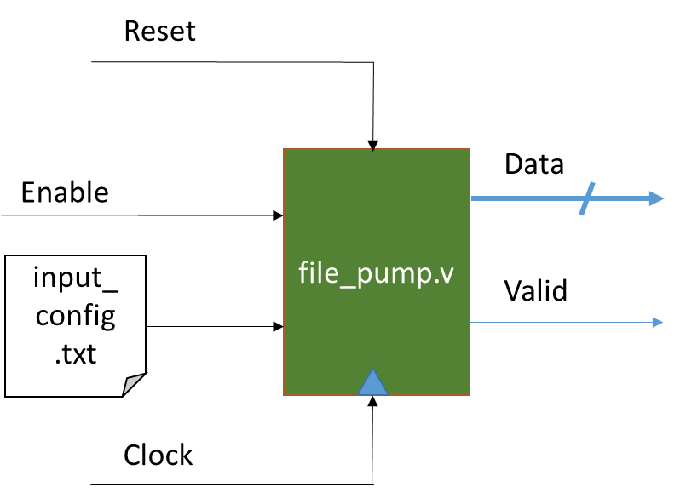

Figure 16: Hexadecimal File Pump Module

The Hexadecimal File Pump module will be written in Verilog as it is easier to integrate a Verilog module in a Verilog test-bench as it allows the module to be constraint with parameters just as VHDL modules can be constraint with generics. Any VHDL modules that needs to be constraint for testing will use a wrapper with the generic values hard coded from the specified test.

The inputs to this module are the reset, clock enable and the data from file to be read. The enable is used so as to use the Hexadecimal File Pump like a buffer so data is read when the rest of the system is capable of taking the next piece. The data read from the file will be a set width so that the correct data width can be set in the parameters of the module. The data format that is extracted is hexadecimal.

**3.2.2. Barrel Shifter**

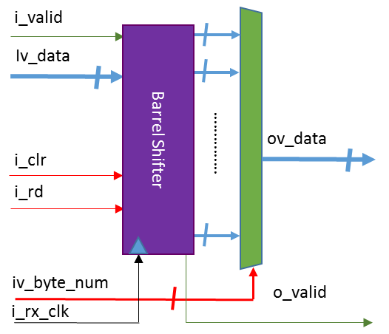

Figure 17: Barrel Shifter Module

The Barrel Shifter module will be coded in VHDL to coincide with the rest of the design as will all other modules specified in this report other that the Hexadecimal File Pump. This module will simply stores the inputted data in a shift register fashion and extracts the data using a large MUX structure to select the correct starting byte depending on the input byte number and if the read enable is set high. The barrel store is cleared to all zeros when the clear signal is set high.

The Barrel Shifter module is a generic module as is it will be reused multiple times and it will be easily altered by defining different values for the input and output data widths.

**3.2.3. Double Data Rate Converter**

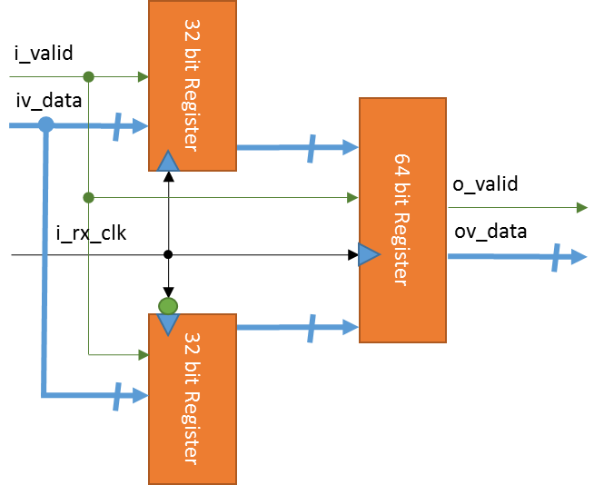

Figure 18: Double Data Rate Module

This module will be used to convert the 32 bit double data rate to a 64 bit single data rate on the input clock provided by the XGMII interface. The Waveforms for this particular module can be seen in Figure 19. The 32 bit input data is registered on both the rising and falling edge of the clock and are then both registered values are concatenated together and re-registered on the rising edge of the clock.



Figure 19: Double Data Rate Waveform

**3.3. XGMII FCS Removal FSM**

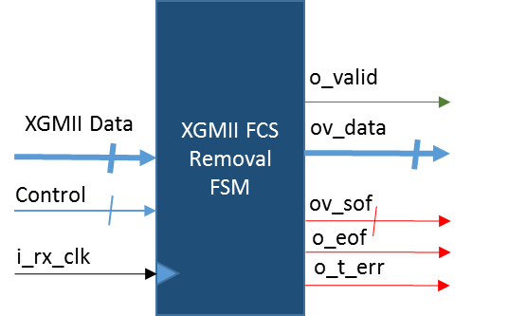

Figure 20: XGMII FCS Removal FSM Module

This module is essential as it is needed to determine when a frame has been detected on the input of the overall design. Prior to the two FSMs in this module the Double Data Rate Converter is placed so as to convert the 32 bit double data rate to 64 bit single data rate. After this the XGMII FSM will decode the data and then then the FCS Removal FSM will detect the end of frame, remove the FCS and move the end of frame flag depending if there is data in the 64 bit word or words that the FCS will be removed from. Figure 21 shows how the internal architecture of this sub module will be laid out. If the start of frame is detected in the 0th byte position the start of frame signal leaving this module will be set to binary 01 and to 10 if in the 4th byte position.

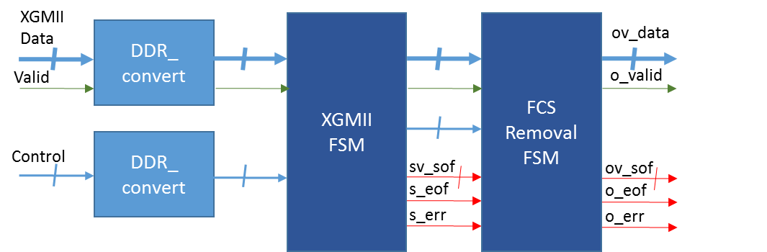

Figure 21: XGMII FCS Removal FSM Architecture

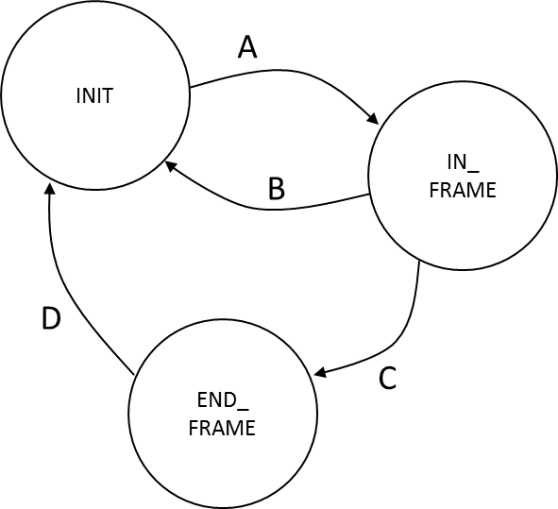

Figure 22: XGMII FSM Diagram

The XGMII FSM will be implemented with only three states, initialise (INIT), in frame (IN_FRAME) and end of frame (END_FRAME). An example of this state machine can be seen in Figure 22 with the transactions between states labelled with a letter. This letter will represent the conditions that must be met for the state machine to switch state.

The conditions for A are that the state machine starts in the INIT state and waits until a valid data is entered to the module and then checks the byte values were the corresponding control bit is set to 1. If the value at byte position 0 or 4 is the start of frame delimiter of hexadecimal value 0xFB then the state machine moves to IN_FRAME, sets the start of frame flag high and passes the data and control to the next state.

Condition B simply switches the state machine to INIT if an error has been detected.

The conditions for C are that the IN_FRAME state will monitor the data until an end of frame of hexadecimal value 0xFD is detected in the same manner as the start of frame but on every byte instead of only in position 0 and 4. When the end of frame is detected a control vector will be outputted to indicate which byte in the 64 bit word contains the end of frame delimiter.

For Condition D the END state simply resets the state machine to INIT. While this is the basic functionality of the FSM there must also be error checking. This is done in IN_FRAME to determine if any frames are in error and if an error is detected the error flag is set to 1 and the frame that is in error will be removed from the data flow. Checking for errors is done in the same fashion as detecting the start of frame and end of frame, by checking the byte value corresponding to the control vector for the hexadecimal value 0xFE.

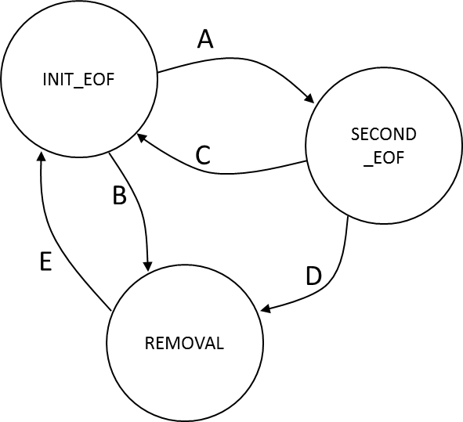

Figure 23: FCS Removal FSM Diagram

Figure 23 shows the diagrammatical representation of the FCS Removal FSM. Similarly to the XGMII FSM the transactions between states are labelled with a letter and this letter represents the conditions that are needed to be met as to switch states. For this state machine to work the end of frame position has to be inspected in two different time slots so as to correctly remove all 32 bits of the FCS.

INIT_EOF looks are the data coming out of the XGMII FSM which will be reference to as time slot one, were as SECOND_EOF examines the data outputted by the XGMII FSM delayed by one clock cycle and will be referred to as time slot two. This must be done as the end of frame delimiter can be in any of the byte positions in the 64 bit word after the data rate is converted from double to single rate.

For conditions B the FSM must detect that an end of frame has been passed through time slot one and the end of frame delimiter is in byte positions 7 to 4 in the 64 bit word otherwise condition A is meet and the state switches to REMOVAL.

The conditions for C are that if there is an incorrect end of frame position in SECOND_EOF go back to the start but if the end of frame delimiter is correctly in byte positions 3 to 0 then the conditions for D are met and the state switches to REMOVAL.

Condition E will simply be to pass the state machine back to INIT_EOF after the FCS is has entered the REMOVAL state. The moving of the end of frame flag will be done in INIT_EOF and SECNOND_EOF.

The output end of frame will be ANDed with the NOT of the output error signal so as to stop an end of frame flag being passed out when an error occurs on the end of frame 64 bit word.

**3.4. Ether-type FSM**

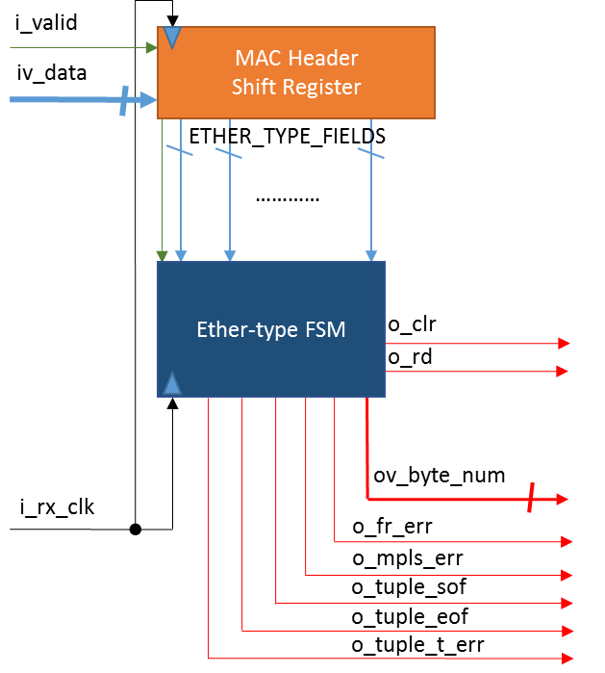

Figure 24: Ether-type FSM Module

This module will be used to decode the Ether-type values in the Ethernet header of incoming frames and to determine were the payload of the frame starts depending on what Ether-type has been detected to be in use. This will be done by storing the Ethernet header in a shift register which stores each 64 bit word that is passed into the Ether-type FSM module until the shift register is full. This register will have the capacity to hold ten 64 bit words as this is how much is required to store the longest possible Ethernet header, see section 2.13. The data will be inspected whenever there is enough header stored to decode an Ether-type value and depending on the first value decoded the state machine will switch states. This state machine will be able to detect the use of IP, Q VLAN, Q in Q VLAN, User defined or Q in Q in Q VLAN, MAC in MAC VLAN and MPLS.

This state machine will be accountable for setting a byte number and read enable high to the Barrel Shifter to output the packet stored as well as controlling the clearing of the barrel store. There will also be a number of errors detected by this state machine which are used to flag if there has been an Ether-type value in the Ethernet header that is unrecognisable or the S bit of the last MPLS label was unfound. These error flags are labelled o_fr_err and o_mpls_err respectively.

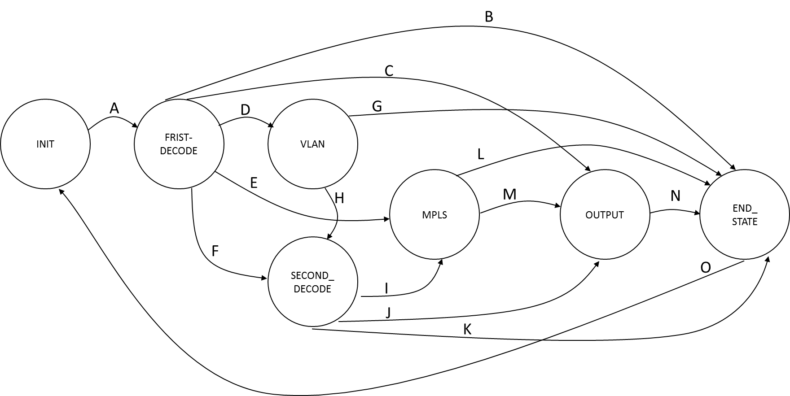It will also pass a propagated transmission error signal to the next state machine to indicate to clear. This must be done as the 5 Tuple FSM could be still processing a packet that does not contain any errors when a new frame could be detected by the XGMII FSM which contains errors that could disrupt the packet leaving the device.

Figure 25: Ether-type FSM Diagram

The state machine diagram stated in Figure 23 is used to describe the different state transactions that will occur which are labelled with letters. These letters represent the conditions that must be met for the state machine to switch between the current state and the next state.

The condition for A will be that a start of frame must be detected in the INIT state to start the state machine which changes state to FIRST_DECODE which decodes the first Ether-type value.

Condition for B will be that if there is an undecodable Ether-type passed in then set the error flag high and switches from the FIRST_DECODE state to the END_STATE state which sets all signals back to zero and initializes the state machine back to INIT and the Barrel Shifter will be cleared. B also incorporates if a received traffic error has been detected, the state machine will reset itself and clear the Barrel Shifter.

The FIRST_DECODE state will move to the OUTPUT state on the condition for C which represents the first Ether-type value decoded being equal to the IP value of 0x0800. If this condition is true then the first byte number will be set depending on the start of frame position as well as the read enable being set high. These starting byte positions are specified in Table 4. The OUTPUT state will simply output and increment the byte number so as to correctly pass the next starting byte to the Barrel Shifter before the next rising edge of the clock. The start of frame flag will also be set high on this condition but will be set low when the state machine enters the OUTPUT state.

The condition for D will be that in the FIRST_DECODE state a stacked VLAN type has been decoded which implies the value 0x88A8 is implemented as the first Ether-type and therefore the state machine moves to the VLAN state which will decode the next VLAN tag to determine the type of stacked VLAN and will assign a starting byte number depending on the start of frame position and the second VLAN Ether-type decoded. The different types of stacked VLANs can be found in section 2.4.

The state machine will move from the FIRST_DECODE state to the MPLS state under condition E which represents that either MPLS Ether-type for multicast or unicast has been detected to be in use which are of values 0x8848 and 0x8847 respectively. As the states change the byte number will be set to the starting position if the IP equivalent depending on the start of frame position. In the MPLS state the number of MPLS labels will be checked by inspecting the S bit of each label. The number of labels will be detected and the relevant number of extra bytes will be added to the byte number so as to output the correct starting byte number. There will be +4 bytes for every MPLS label detected.

The condition for F will be that in the FIRST_DECODE state Q VLAN is detected to be in use and after the VLAN tag the second Ether-type must be decoded to determine if IP or MPLS is implied so the state machine moves to SECOND_DECODE. On this condition an inter-state machine flag will be set to indicate to the MPLS state Q VLAN was implemented.

Condition G will switch the state machine from the VLAN state to the END_STATE state which is due to an incorrect Ether-type value being detected. If this condition is met the Ether-type error is flagged and the Barrel Shifter will be cleared. This condition also incorporated a receiving traffic error being detected as the state machine will move to END_STATE and clear the Barrel Shifter.

The state machine will move from the VLAN state to the SECOND_DECODE state under condition H. This condition is that the second VLAN tag in the stack was an allowed value and therefore the last Ether-type field in the Ethernet header has to be decoded to determine in IP or MPLS is used. On this condition an inter-state machine flag will be set to indicate to the MPLS state what kind of stacked VLAN was implemented. Also the starting byte number will be set in this state so as to correctly allocate a starting byte for each type of stacked VLAN which also takes into account the start of frame position.

The condition for I will be that MPLS has been detected in the SECOND_DECODE state so the state machine moves to the MPLS state. In the MPLS state the inter-state flags will be used to indicate what type of VLAN has been detected before the MPLS labels. This is important as the labels are offset differently depending on the start of frame position and the type of Ethernet frame format that is used prior to the MPLS labels. Using these signals the position for the S bits of the MPLS labels can be correctly found.

The state machine will move from the SECOND_DECODE state to the OUTPUT state on condition J which represents that the second Ether-type decoded indicates that IP is implemented. If this condition is met the starting byte number is not altered and the read enable will be set high. These starting byte positions are specified in Table 4. The start of frame flag will also be set high on this condition but will be set low when the state machine enters the OUTPUT state.

SECOND_DECODE moves to the END_STATE state due to condition K which characterises that the second Ether-type to be decoded was not a value that represents IP or MPLS being used. If this is true then the Ether-type error flag will be set high and the Barrel Shifter will be cleared. This condition also incorporated if a receiving traffic error has been detected as the state machine will move to END_STATE and clear the Barrel Shifter.

Condition L will be used to explain the transaction between the MPLS state and the END_STATE state. This condition will be that when in the MPLS state and trying to determine how many labels are amended the S bit is not set high for any number of the labels and therefore the MPLS error flag will be set high and the Barrel Shifter will be cleared. This condition also incorporated a receiving traffic error being detected as the state machine will move to END_STATE and clear the Barrel Shifter.

The state machine moves from the MPLS state to the OUTPUT state due to condition M which denotes that the correct number of MPLS labels being detected and accounted for. Depending on the number of labels found to be amended to the frame, the starting byte number is incremented by 4 for each label. On this condition the read enable will be set high. The start of frame flag will also be set high on this condition but will be set low when the state machine enters the OUTPUT state.

Condition N will be met when the input end of frame flag is set high and transitions the state machine from OUTPUT to END_STATE. On this condition the output end of frame flag and Barrel Shifter clear will be set high but will be set low when the state machine enters the END_STATE state. This condition also incorporated a receiving traffic error being detected as the state machine will move to END_STATE and clear the Barrel Shifter.

For condition O, which simply resets the state machine so that it will be ready to detect the next frame, the state machine switches from the END_STATE state to the INIT state.

|  |  |  |  |  |  |  |
| --- | --- | --- | --- | --- | --- | --- |
| ***Start of Frame Byte Position*** | ***IP*** | ***Q VLAN*** | ***Q in Q VLAN*** | ***Q in Q in Q VLAN*** | ***MAC in MAC VLAN*** | ***MPLS (per label)*** |
| ***0*** | 22 | 26 | 30 | 34 | 50 | +4 |
| ***4*** | 18 | 22 | 26 | 30 | 46 | +4 |

Table 4: Starting Byte Positions

**3.5. 5 Tuple FSM**

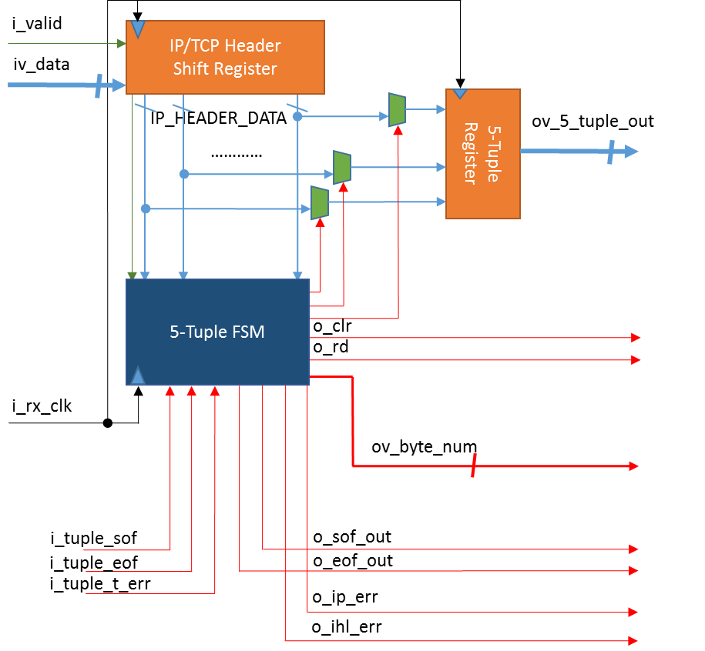

Figure 26: 5 Tuple FSM Module

This module will be used to extract the 5 Tuple from the network layer and transport layer headers by storing these headers into a separate shift register than the Barrel Shifter which will be used to store the IP packet while the 5 Tuple is being extracted. Once there is enough data stored in the IP/TCP Header Shift Register the fields can be extracted and concatenated together into the 5 Tuple register.

The state machine must take into account if there is options used in the IP header so the internet header length field is used to decipher if there are five or six 32 bit fields used to represent the header. The IP/TCP Header Shift Register must be 256 bit in size to deal with four 64 bit words as this is how many 64 bit words required to get all the information for the 5 Tuple.

The state machine is responsible for outputting the starting byte number and incrementing it every clock cycle as well as setting the read enable and the clear to the Barrel Shifter. As well as this the state machine must also output a start of frame and end of frame to indicate to the next stage when the IP packet starts and finishes.

This state machine will check for errors in the packet header fields. The internet header length field will be checked to determine if IP options are in use and if the value inspected is not a decimal value of 5 or 6 then the signal o_ihl_err is set to one. The protocol field in the IP header will also be inspected to determine the transport layer protocol used and if there is a value that is not 0x01, 0x06 or 0x11 then the o_ip_err is set to one. These error flags will be set to zero in the last state of the FSM.

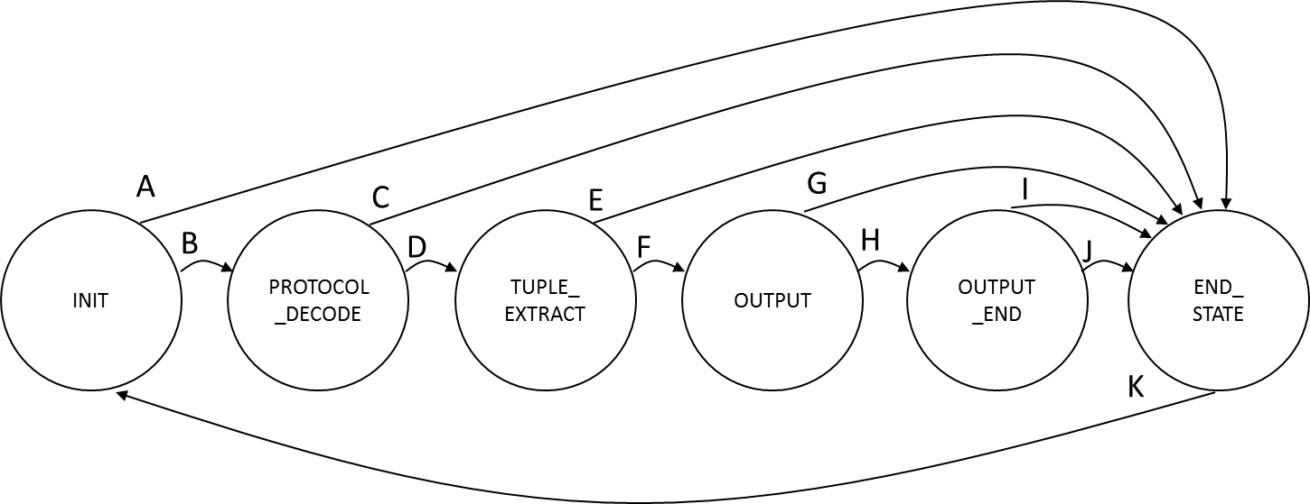When the IP protocol field indicates that ICMP is in use then the 5 Tuple will be produced differently than if TCP or UDP is detected to be used. The 5 Tuple will not contain and transport layer source and destination port numbers as when ICMP is implemented in the IP header, the payload of the IP packet does not start with the transport layer header but the IP header and first 64 bit of the transport layer header of the packet that is using the ICMP protocol to correct a problem. Therefore the 5 Tuple will indicate to the next stage the ICMP is used and the IP source and destination addresses that are used.

Figure 27: 5 Tuple FSM Diagram

The state machine diagram stated in Figure 27 is used to describe the different state transactions that will occur which are labelled with letters. These letters represent the conditions that must be met for the state machine to switch between the current state and the next state.

The conditions for A are that if an internet header length error is detected the state machine moves from the INIT state to the END_STATE state. The internet header length error flag and the Barrel Shifter clear will be set to one. The END_STATE is used to zero all signals before the next valid packet is passed to this state machine.

B will be the condition for the state machine to switch between the INIT state and the PROTOCOL_DECODE state and is used to signify that a correct internet header length was detected. For this condition a flag will be set to indicate to later states that either 5 or 6 was detected for the internet header length. This will be used to extract the transport layer protocol source and destination ports depending if IP options are in use.

The state machine moves from the PROTOCOL_DECODE state to the END_STATE state on condition C which is used to represent that the IP protocol field value is one that is not recognised by the state machine. For this condition the IP protocol field error flag and the Barrel Shifter clear signal will be set high. This condition will also be used to epitomise a receiving traffic error being detected. If this condition is met the clear signal is set high so as to clear the Barrel Shifter of any stored packet data.

The condition D will switch the state machine from the PROTOCOL_DECODE state to the TUPLE_EXTRACT state and will be used to denote that an IP protocol value in the IP header was an allowed value. If the state machine detect the ICMP is in use then an inter-state machine flag will be set high to indicate to the later stages of the state machine that it has been detected. This is done as the 5 Tuple will not contain the source and destination port numbers of the transport layer protocol.

Condition E is used to characterise that a receiving traffic error has been detected and caused the state machine to switch states from the TUPLE_EXTRACT state to the END_STATE state. The clear signal will be set high so as to empty the Barrel Shifter of any packet data.

The state machine moves from the TUPLE_EXTRACT state to the OUTPUT state due to condition F which is used to symbolise when the 5 Tuple is correctly extracted. When the state machine switches between these states the read enable is set high. The starting byte number is left to start at 0 as there is no need to clip the packet at any point.

The condition G is used to indicate that a receiving traffic error has been detected and caused the state machine to switch states from the TUPLE_EXTRACT state to the END_STATE state. The clear signal will be set high so as to empty the Barrel Shifter of any packet data.

Condition H is used to signify that an end of frame flag has been detected and will cause the state machine to switch between the OUTPUT state and the OUTPUT_END state. When this transaction occurs a count will be incremented. This count will be used in the OUTPUT_END state to correctly extend the read enable so that all of the packet data will be read out as the 5 Tuple extraction causes a hold in the data flow until it is correctly extracted. In the OUTPUT_END state the internet header length flags will be used to correctly count the number of 64 bit words that are still required to be passed out of the Barrel Shifter module.

The condition I is used to symbolise that a receiving traffic error has been detected and caused the state machine to switch states from the TUPLE_EXTRACT state to the END_STATE state. The clear signal will be set high so as to empty the Barrel Shifter of any packet data.

The state machine switches on condition J between the OUTPUT_END state and the END_STATE state which is used to represent that all of the packet data has been outputted correctly. Under this condition the end of frame flag is set high.

Condition K will switch the state machine between the END_STATE state and the INIT state and is used to denote the initialization of the state machine. On this transaction the read enable and starting byte number are zeroed.

**4. Design and Verification**

This section of the report will cover the design methodologies that will be taken note of while the design is to be coded and verified, the top level entity declaration and the verification process that will be carried out so that all functionality is tested.

The design will have to be heavily tested to determine if there is any conditions that cause any of the state machines to get stuck in a state and if this is found to be possible then counter measures will be taken to improve the code. Each sub module will be verified as it is added to the design so as to construct the top level while the each sub module is completed. Examples of the verification process will be shown in the form of screen captures of the ModelSim wave window. Any difficulties that arise while the sub modules are being coded and debugged will be commented on after the verification waveforms are analysed.

**4.1. Design methodologies**

To implement a hardware design on to a FPGA the code must be converted to a bit file that is generated using a software tool such as Xilinx’s Vivado from hardware description languages such as VHDL and Verilog. VHDL will be used for the designing of the sub modules shown in the design section of this report and Verilog will be used to produce test-benches and the Hexadecimal File Pump module in section 3.2.1. This will be done so as to gain experience with both types of hardware description languages.

The code for this design must be produced for a FPGA device and therefore must be strictly registered. This is done to divide up the combinational logic blocks between register stages so that the computation of the logic is completed before the next rising or falling edge of the digital clock the system is registered on. For this design the rising edge of the clock will be used to register the logic.

For this design Mentor Graphics ModelSim simulation tool will be used to compile and simulate the different modules. This software is very robust with many capabilities such as the ability to use a script to compile and simulation quickly. Scripts that can be used to ModelSim are of the “.do” file type and use TcL [42] syntax. For this report this method of scripting will be used so as to quickly recompile and resimulate the modules to speed up the debugging process.

The coding technique to produce the state machines required for this design will use a CASE structure to define different states. A TYPE will be defined and assigned to a signal and this signal will be used to represent the state machines current state. The CASE structure will be used will this signal to define what occurs in each state and passes through the states depending on the criterial stated in the System Architecture of this report. These CASE structures will be placed directly into a registered process so as to combine the combinational logic and signal registering.

**4.2. Top Level Entity Declaration**

In this section the top level entity declaration is shown so as to specify the module I/O. The top level entity declaration can be found in Figure 28.

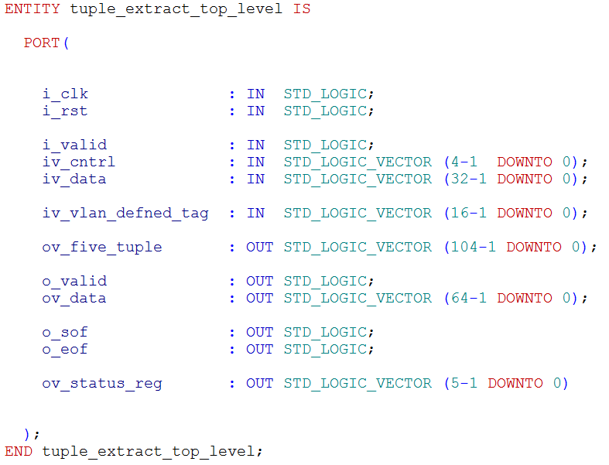

Figure 28: Top Level Entity Declaration

**4.3. Verification**

Verification is different from testing as verification is the process of testing and debugging so that a module has the correct functionality whereas testing is done to show that a module functions after it is verified. The verification to be done in this design will be done with a test case methodology were each test has a different functionality to verify. This section of the report states the test bench configurations that will be used to test the sub modules and the different test cases that will be ran to attempt to completely cover all possible scenarios. These scenarios are the different ways in which data can be inputted to the sub modules under test such as testing forced errors in different places in an incoming frame to determine that the state machines can correctly detect the errors and reinitialize themselves. The scenarios that are to be inputted will test extensively all possible configuration so that all the functionality of the circuit is verified.

**4.3.1. Hexadecimal File Pump Verification**

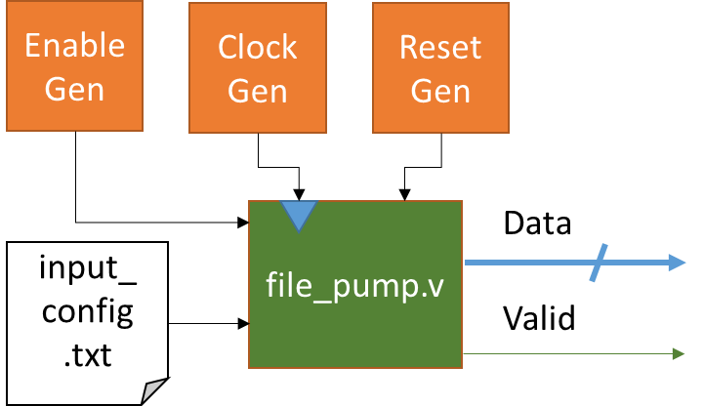

Figure 29: Hexadecimal File Pump Test Bench Configuration

Above is the test bench configuration that will be used to verify the Hexadecimal File Pump module. This module will read hexadecimal values from an input file named input_config.txt which will contain the input stimulus for the other test benches required to be produced for this report. The input text file for this test will contain the values 0x00, 0x09, 0x08, 0x07, 0x06, 0x05, 0x04, 0x03, 0x02, 0x01, 0x10 and 0x00.

**4.3.1.1. Hexadecimal File Pump Waveform Analysis and Debugging Problems**

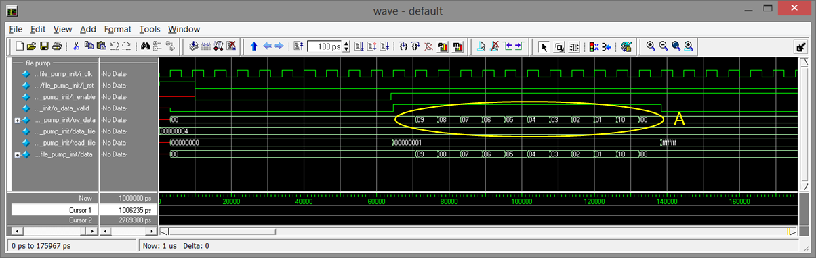

Figure 30: Hexadecimal File Pump Waveforms

Figure 30 shows the waveform capture of the functional Hexadecimal File Pump. It can be seen that the outputted values, denoted by A, of this test coincide with the values previously stated to be stored in the input_config.txt file. The Hexadecimal File Pump is shown to stop outputting data when the last line of the text file is read. This is indicated by the read_file signal changing to 0xFFFFFFFF which represents the file has been read to the last line.

The only problem that arouse when producing this module was figuring out how to read the test file until empty which was quickly solved by examining example code and adopting a similar methodology.

**4.3.2. Double Data Rate Converter Verification**

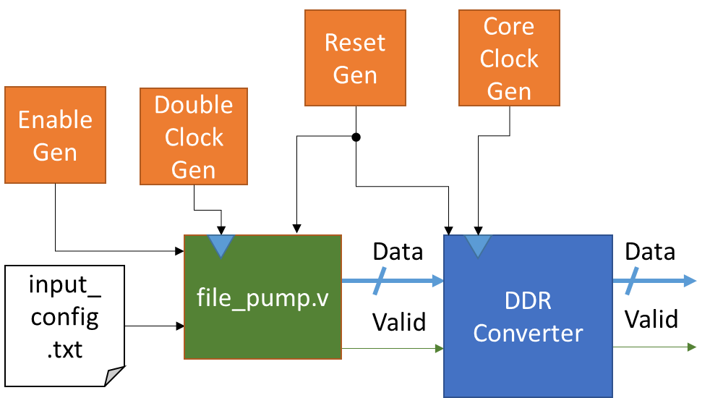

Figure 31: Double Data Rate Converter Test Bench Configuration

The above diagrams shows the arrangement of the test bench that will be constructed for the testing of the Double Data Rate Converter module. The testing for this module will be a simple test to show that the data being passed in is converted to the single data rate. The Hexadecimal File Pump module will be reading at a clock that is twice the speed of the core clock as that the data being passed in the Double Data Rate Converter must change on the rising and falling edge of the core clock. This will be the method taken with all of the test benches which use the XGMII FCS Removal FSM module as the Double Data Rate Converter will be used to convert the 32 bit XGMII double data rate to 64 bit single data rate. The data that will be inputted is shown in Table 5.

|  |  |
| --- | --- |
| ***Rising Edge*** | ***Falling Edge*** |
| 0xFFFFFFFF | 0x00000009 |
| 0x00000008 | 0x00000007 |
| 0x00000006 | 0x00000005 |
| 0x00000004 | 0x00000003 |
| 0x00000002 | 0x00000001 |
| 0x00000010 | 0x00000000 |

Table 5: Double Data Rate Converter Inputs

**4.3.2.1. Double Data Rate Converter Waveform Analysis and Debugging Problems**

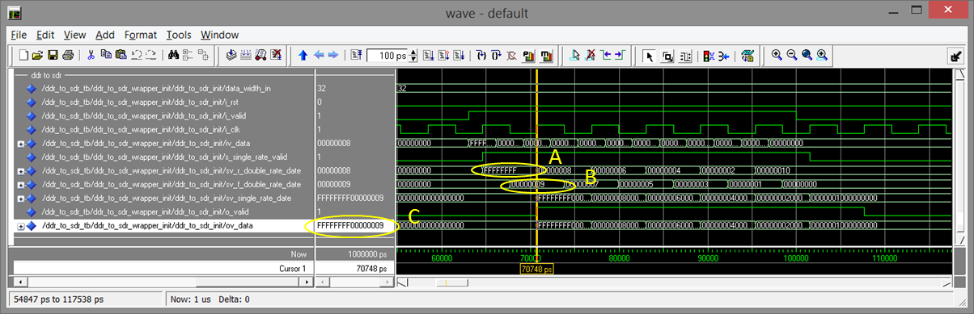

Figure 32: Double Data Rate Converter Waveforms

The waveform capture above show that the data being inputted to this module changes before and after the rising edge of the core clock. It can be seen that the input data is registered on the rising and falling edge of the clock into the registers sv_r_double_rate_data and sv_f_double_rate_data denoted by A and B. These registers are concatenated together and registered on the next rising edge of the clock which can be observed with the signal ov_data represented by C. This signal can be seen to contain the value 0xFFFFFFFF00000009 where the cursor has been placed. No problems arouse while producing this module.

**4.3.3. XGMII FCS Removal FSM Verification**

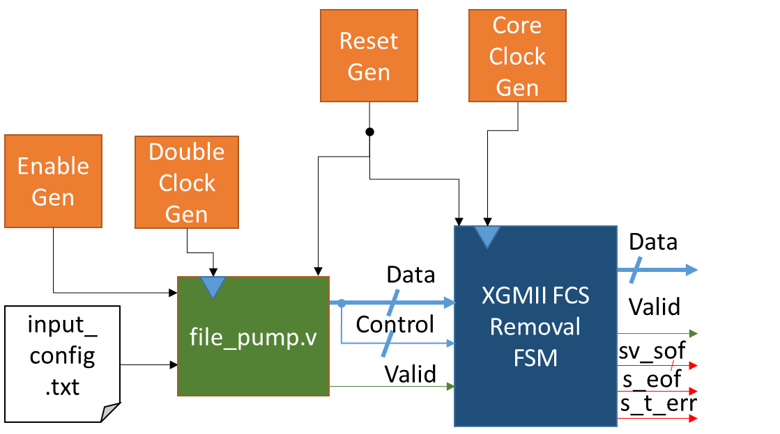

Figure 33: XGMII FCS Removal FSM Test Bench Configuration

Figure 33 shows the configuration of the test bench that will be constructed to test the XGMII FCS Removal FSM. As before the file pump will read the data stored in the input_config.txt out on a clock twice the speed of the core clock. There will be two test cases ran which are explained in Table 6. Part of the data that is inputted to this module is used as the XGMII control as it is concatenated together in the input test file.

|  |  |  |
| --- | --- | --- |
| ***Test Case*** | ***Description*** | ***Actions*** |
| 0 | This test will verify the start of frame positions and the end of frame positions are decodable | * First four frames will have the start of frame in the 0th byte position with the end of frame tested in all byte positions * Second four frames will have the start of frame in the 4th byte position with the end of frame tested in all byte positions |
| 1 | This test will verify that receiving traffic errors are detected | * Four error test frames which will be; in the preamble of start of frame word , in the 32 bits after the start of frame word, on the end of frame word and in frame |

Table 6: XGMII FCS Removal FSM Test Cases

The two FSM will be tested together as there functionality can be easily assessed together. The test frames will only have a basic Ethernet Frame structure as there will be no IP header as it is unneeded to test this module. The CRC amended to the Ethernet frame will be set to 0xCCCCCCCC. Not all waveforms for each test frame for this module will be analysed in the report but the will be placed in Appendix A for reference.

**4.3.3.1. XGMII FCS Removal FSM Waveform Analysis and Debugging Problems**

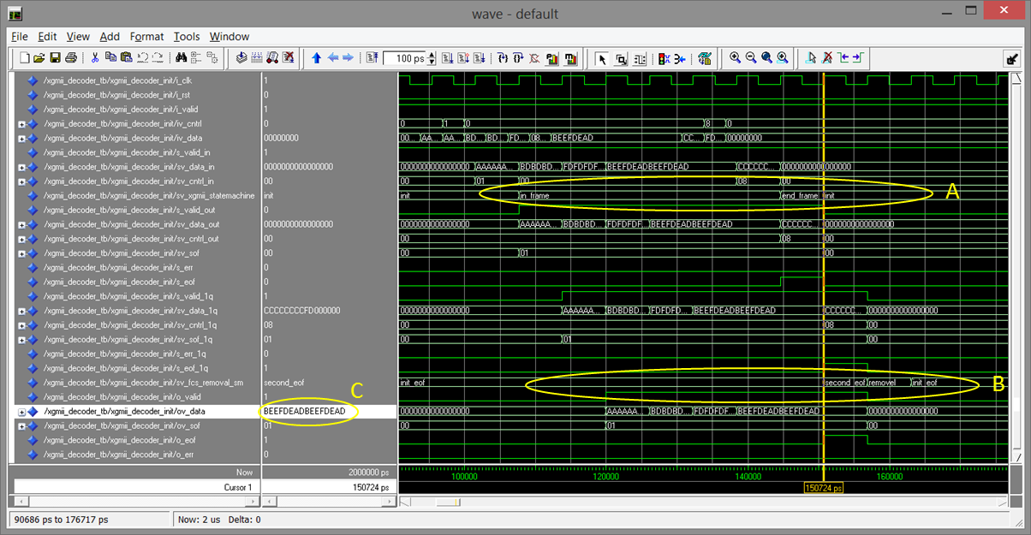

Figure 34: XGMII FCS Removal FSM Test Case 0 Waveforms

The above waveform capture shows the first test frame passing through the XGMII FSM and the FCS Removal FSM both denoted by sv_xgmii_statemachine and sv_fcs_removal_sm respectively denoted by A and B. The waveforms show the two state machines cycling through the different states of the state machines defined in the section 3.3 and performing in the correct manner. The last 64 bit word to be passed out has the FCS clipped which is represented by C. The other tests ran have shown all other configuration are correctly decoded by the XGMII FSM and are properly clipped of the Ethernet frame FCS by the FCS Removal FSM. The waveforms show how the start of frame signal is set to the binary word value 01 indicating that the start of frame was in the 0th byte position and also the end of frame flag going high on the last 64 bit word for the frame. These signals are correctly set so that the Ether-type FSM can correctly analyse the frame.

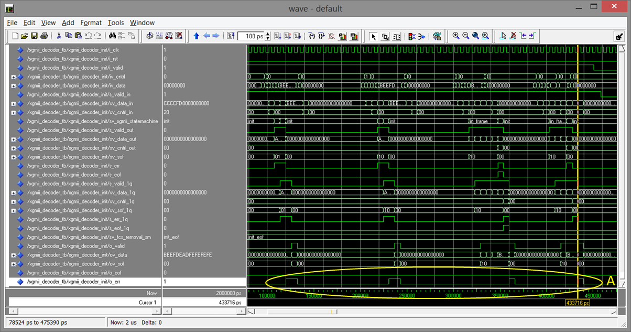

Figure 35: XGMII FCS Removal FSM Test Case 1 Waveforms

Figure 35 shows the waveform capture produced after test case 1 which shows the output error signal going high four times which is represented by A. The first test frame has an error in the preamble of the frame which was deemed to be a valid traffic error and must be accounted for. The second test frame has the error to be detected on the 32 bits inputted after the start of frame which can be seen in the highlighted signals that the error is in the byte position 0. The third test frame has an error on the end of frame word and as can be seen the end of frame is not set and only the error signal is set high. The final test frame has an error in the frame which shows that this state machine follows the correct functionality that is desired.

There were a few different debugging problems that occurred in the implementation of this design as side from simple syntax errors. The first notable problem was to correctly clip the FCS from the frame which was due to trying to deal with two separate time slots and trying to find the correct configuration to decode the end of frame positions, clip the FCS and move the end of frame flag when needed. The second problem was the error detection priority. After testing the error to be detected in the same word as the end of frame delimiter this problem was found as the end of frame flag was being set high and the error wasn’t being detected. This was due to the priority of the IF statements used which put the end of frame detection first which was fixed my switching the end of frame detection with the error detection. This meant that the end of frame could be high at the same time as the error signal which was resolved by ANDing the end of frame flag signal with the NOT of the error flag signal.

**4.3.4. Ether-type FSM Verification**

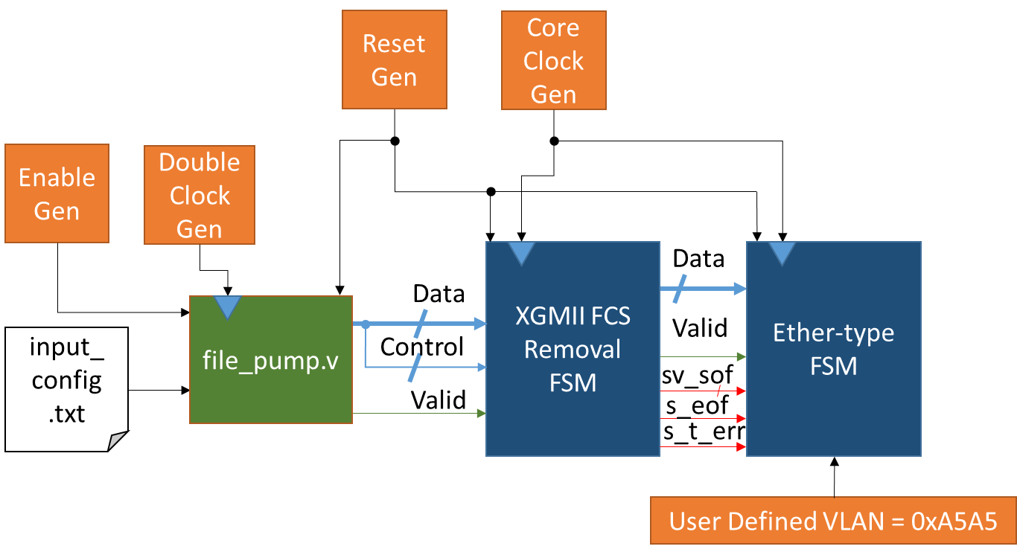

Figure 36: Ether-type FSM Test Bench Configuration

The configuration of the test bench shown in Figure 36 will be constructed to test the Ether-type FSM. As before the file pump will read the data stored in the input_config.txt out on a clock twice the speed of the core clock. The testing for this module must cover all configurations of the Ethernet frame that are stated previously in this document which employ different Ether-types such as VLAN, MPLS or VLAN with MPLS. These test cases are explained in Table 7. Part of the data that is inputted to this module is used as the XGMII control as it is concatenated together in the input test file.

|  |  |  |
| --- | --- | --- |
| ***Test Case*** | ***Description*** | ***Actions*** |
| 0 | Test all frame configurations separately | * First and second frames will use IP * Third and fourth frame will use Q VLAN (8100 and 9100 configurations, see section 2.4) * Fifth and sixth frames will use Q in Q VLAN (88A8/8100 and 9200/9100 configurations, see section 2.4) * Seventh and eighth frames will use Q in Q in Q VLAN (user_defined/88A8/8100 and 9300/9200/9100 configurations, see section 2.4) * Ninth and tenth frames will use MAC in MAC VLAN (88A8/88E8|88A8/8100, see section 2.4) * Eleventh to sixteenth frames will use MPLS with increasing number of labels for 1 to 6, all frames have the same start of frame position in byte 0 * Seventeenth to twenty second frames will use MPLS with increasing number of labels for 1 to 6, all frames have the same start of frame position in byte 4 * All sets of frames have different start of frame positions |
| 1 | Test Q VLAN with ranging number of MPLS labels | * First 7 test frames have the start of frame in byte position 0, the first frame does not have MPLS * Second 7 test frames have the start of frame in byte position 4, the first frame does not have MPLS |
| 2 | Test Q in Q VLAN with ranging number of MPLS labels | * First 7 test frames have the start of frame in byte position 0, the first frame does not have MPLS * Second 7 test frames have the start of frame in byte position 4, the first frame does not have MPLS |
| 3 | Test Q in Q in Q VLAN with ranging number of MPLS labels | * First 7 test frames have the start of frame in byte position 0, the first frame does not have MPLS * Second 7 test frames have the start of frame in byte position 4, the first frame does not have MPLS |
| 4 | Test MAC in MAC VLAN with ranging number of MPLS labels | * First 7 test frames have the start of frame in byte position 0, the first frame does not have MPLS * Second 7 test frames have the start of frame in byte position 4, the first frame does not have MPLS |
| 5 | Test different lengths of frames | * First 9 test frames have the start of frame in byte position 0, the frames payload increase in size from 2 output byte numbers to 10 * Second 9 test frames have the start of frame in byte position 4, the frames payload increase in size from 2 output byte numbers to 10 |
| 6 | Test the different types of receiving traffic errors that should be detected | * Four error test frames which will be; in the preamble of start of frame word , in the 32 bits after the start of frame word, on the end of frame word and in frame |
| 7 | Test the Ether-type error and MPLS error detection in each state | * First and second frames will test the ether-type error detection in the FIRST_DECODE state * Third and fourth frames test the ether-type error detection in the SECOND_DECODE state after a Q VLAN frame is decoded in FIRST_DECODE * Fifth and sixth fourth frames test the ether-type error detection in the SECOND_DECODE state after a Q in Q in Q VLAN frame is decoded in FIRST_DECODE * Seventh to tenth frames test the ether-type error detection in the VLAN state testing post decode of Q in Q VLAN and MAC in MAC VLAN * Eleventh and twelfth frames test that MPLS errors are detected * Thirteenth and fourteenth frames test that MPLS errors are detected when Q VLAN is used (8100 and 9100 configurations, see section 2.4) * Fifteenth and sixteenth frames test that MPLS errors are detected when Q in Q VLAN is used (88A8/8100 and 9200/9100 configurations, see section 2.4) * Seventeenth and eighteenth frames test that MPLS errors are detected when Q in Q in Q VLAN is used (user_defined/88A8/8100 and 9300/9200/9100 configurations, see section 2.4) * Nineteenth and twentieth frames test that MPLS errors are detected when MAC in MAC VLAN is used (88A8/88E8|88A8/8100, see section 2.4) * All sets of frames have different start of frame positions |

Table 7: Ether-type FSM Test Cases

Not all waveforms for each test frame for this module will be analysed in the report but some will be placed in Appendix B for reference which will be the waveforms for test case 0 and 7 as these cover the most functionality. There will be three waveform captures that will be analysed that will be a waveform capture the largest configuration of VLAN and MPLS which will be a MAC in MAC VLAN tagged frame will six MPLS labels, a waveform capture to assess the state machines behaviour when a receiving traffic error is flagged and also there will be a waveform capture to examine the state machines ability to detect Ether-type errors and MPLS errors (refer to section 3.1.3).

**4.3.4.1. Ether-type FSM Waveform Analysis and Debugging Problems**

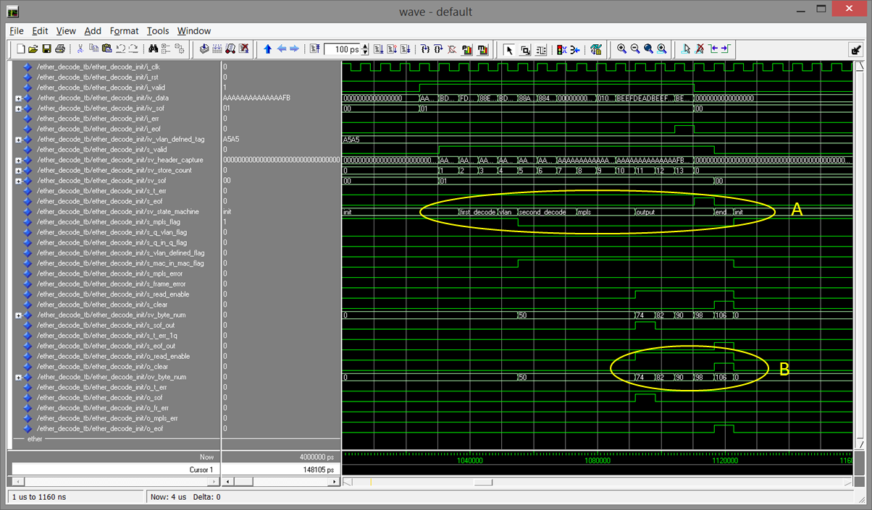

Figure 37: Ether-type FSM Test Case 4 test frame 7 Waveforms

The above waveform capture shows the full functionality of the ether-type FSM when an error condition is not introduced. A denoted the state machine cycling through the different states to correctly decode the incoming frame. As it can be seen the FSM goes through all the states defined in section 3.4 showing all states are functional. B represents the outputted signals to the Barrel Shifter showing the read enable going high as the output starting byte number is incremented to 74 due to six MPLS labels being detected showing correct decoding of the frame. The clear signal can be seen to go high on the last starting byte number before the starting byte number is zeroed which will correctly pass out the last 64 bit word of the IP packet from the Barrel shifter starting at byte 106 and clear the Barrel Shifter after.

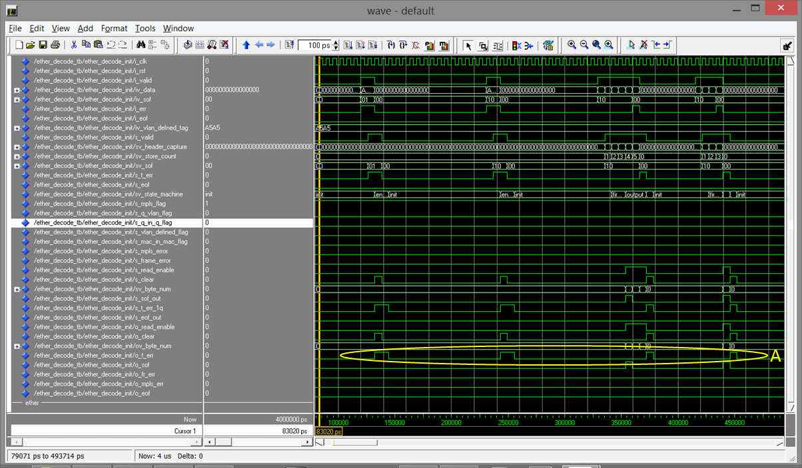

Figure 38: Ether-type FSM Test Case 6 Waveforms

Figure 38 is the waveform capture of test case 6 which is a straight copy of the XGMII FCS Removal FSM test case 1 which is used to test receive traffic errors in different positions in the frame. A represents the error signal being passed out of the state machine as this will be passed on to the 5 Tuple FSM. The read enable and output starting byte number only ever get set when there is an error detected on the end of frame word or in frame which is correct functionality as they are not set when an error is detected on the start of frame.

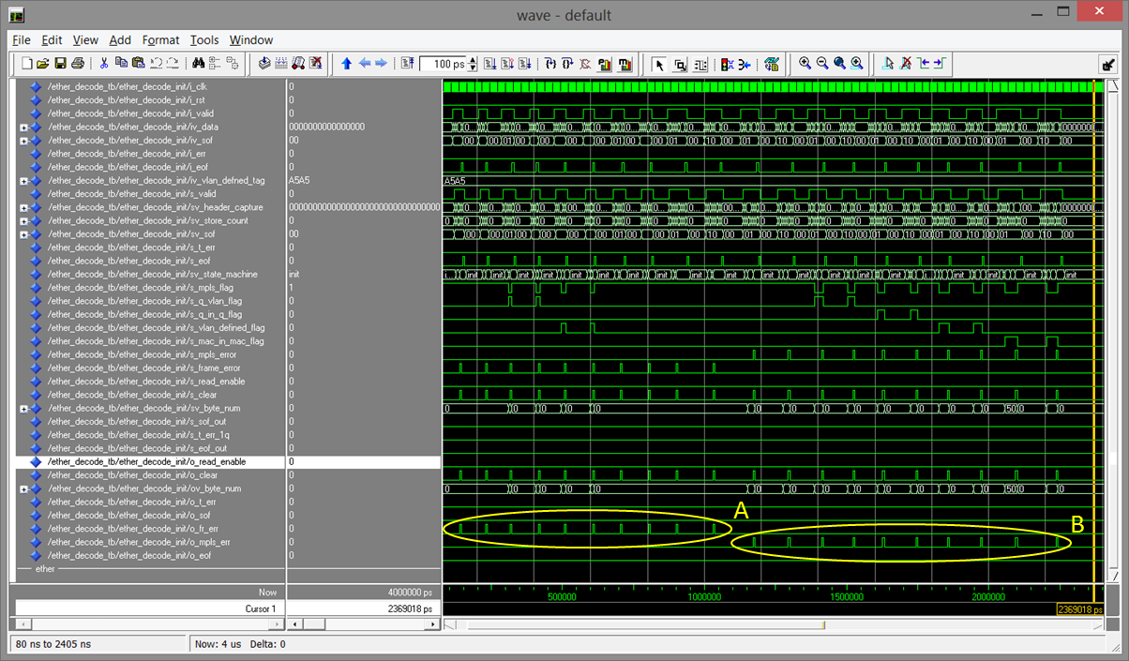

Figure 39: Ether-type FSM Test Case 7 Waveforms

Above shows the waveform capture of test case 7 which was ran to verify that Ether-type errors and MPLS errors were detected properly in every state that it is possible to detect these errors. A denoted the Ether-type errors being flagged high as the errors are detected in the order that is specified in Table 7 under test case 7. Similarly B represents the MPLS errors detected in the order specified in Table 7. The waveforms above are correct and shows that the Ether-type FSM is fully functional.

While the test cases where being ran there were a number of problem detected in the code with many of them being minor and only a few being major. There was one minor error which unfortunately was unseen for a period of time and severely hindered the design which took longer than expected to find and correct as it was a small syntax error in an IF statement that was copied a number of times through the code which use the more than or equal to comparator (“<=”) instead of equal to (“=”). Other than this minor error no other minor errors consumed a lot of time to correct.

The few major errors that had to be corrected started with the difficulty of examining the correct Ether-type feels depending on what was decoded first. This was quickly solved by using spreadsheets to calculate the correct positioning of the Ether-types. A very similar problem with the positioning of the S bit of the MPLS labels depending on what was decoded prior also affected the design but was also solved by the use of spreadsheets. After the normal functionality of the state machine was found to be correct the receiving traffic error detection was tested which indicated an error between how the XGMII FCS Removal FSM outputted the data and error to the Ether-type FSM which caused an unexpected Ether-type error which was easily fixed by outputted the data and not holding it when a receiving traffic error is detected by the FCS Removal FSM. Other that these relatively easy debugging problems the design was produced with ease.

**4.3.5. Barrel Shifter Verification**

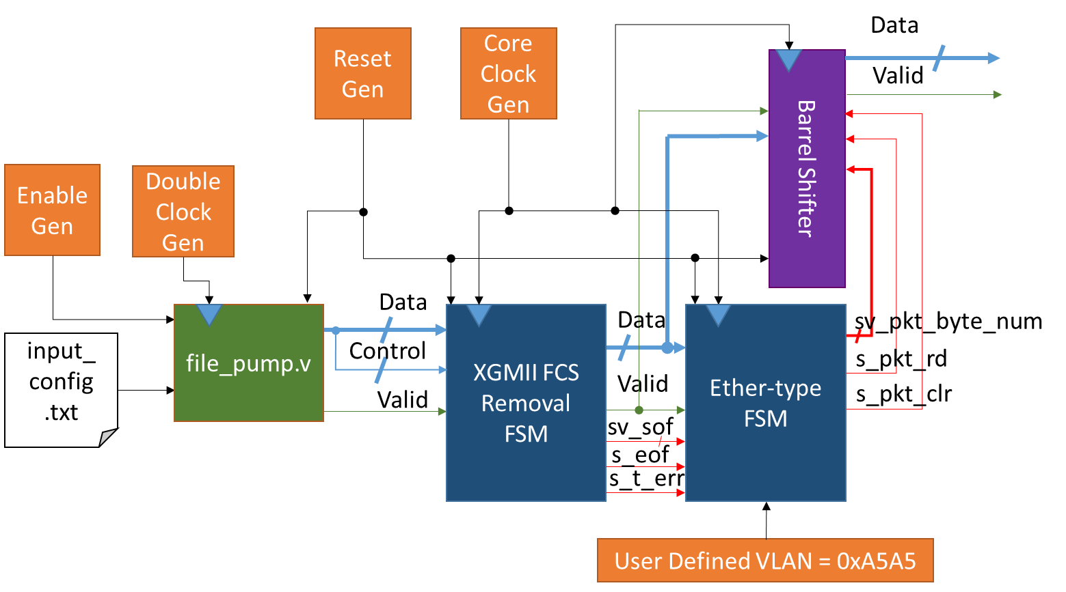

Figure 40: Barrel Shifter Test Bench Configuration

Above states the test bench configuration that will be used to test the Barrel Shifter module. This module will be verified after the XGMII FCS Removal FSM module and the Ether-type FSM module are completed and verified, as the Ether-type FSM will interface with the Barrel Shifter and this is the best configuration to test the combined functionality after all the modules needed are completed. The test to determine of the Barrel Shifter preforms properly for the desired outcome a starting byte number, signified by the sv_pkt_byte_num, and a read enable, signified by i_pkt_rd, will be inputted to extract data from the barrel store. These input signals will be set by the Ether-type FSM and therefore are used to extra the payload of the Ethernet frame.

For the test that is to be done to verify that the Barrel Shifter works correctly the input stimulus will be a standard Ethernet frame with the Ether-type equal to the value for IP. This will cause the Ether-type FSM to perform its quickest decode and to pass out the starting byte number and read enable of where the Ethernet frame payload begins. For this test the Ethernet frame payload is filled with the 32 bit hexadecimal word 0xDEADBEEF which is repeated five times in the input test file. This will result in three 64 bit words being passed out of the Barrel Shifter with the first two containing 0xDEADBEEFDEADBEEF and the last containing 0xDEADBEEF00000000. Part of the data that is inputted to this module is used as the XGMII control as it is concatenated together in the input test file.

**4.3.5.1. Barrel Shifter Waveform Analysis and Debugging Problems**

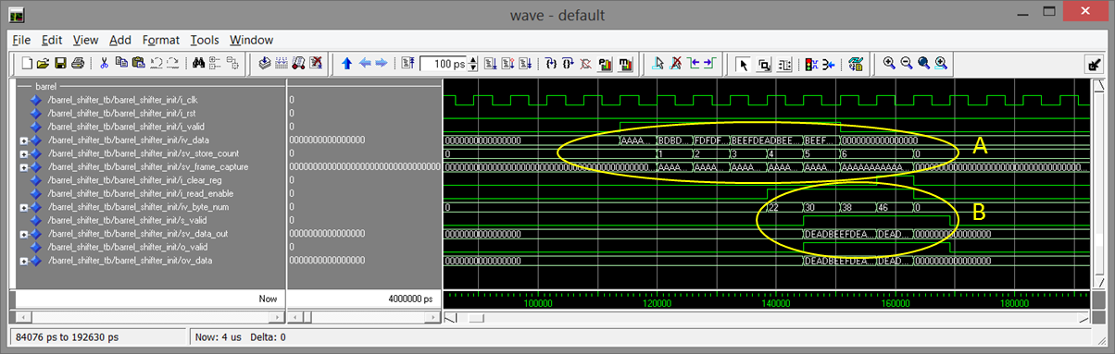

Figure 41: Barrel Shifter Waveforms

The above waveform shows the testing of the Barrel Shifter module. It can be seen that the input data, denoted by iv_data, is registered into the barrel register, signified by sv_frame_capture on every input valid data clock cycle and the count, represented by sv_store_count, is used to find the next positon in the sv_frame_capture register to place the next valid 64 bit word inputted in the correct place without over lapping the data currently stored both represented by A. It can be seen that the cycle after the read enable is set high, the requested data is outputted denoted by B.

As stated in the previously the output is to be expected three 64 bit words being passed out of the Barrel Shifter with the first to be two containing 0xDEADBEEFDEADBEEF and the last containing 0xDEADBEEF00000000. This result can be seen to be passed out of the Barrel Shifter. There is an overhang on this packet as this is due to the end of frame byte being placed in the 7th byte position prior to the Ether-type FSM. This overhang does not occur when the end of frame position is in any other location other than the 7th byte position. No other testing is required to verify that the Barrel Shifter module preforms correctly. There was no problems that arouse while producing the code for this sub module.

**4.3.6. 5 Tuple FSM Verification**

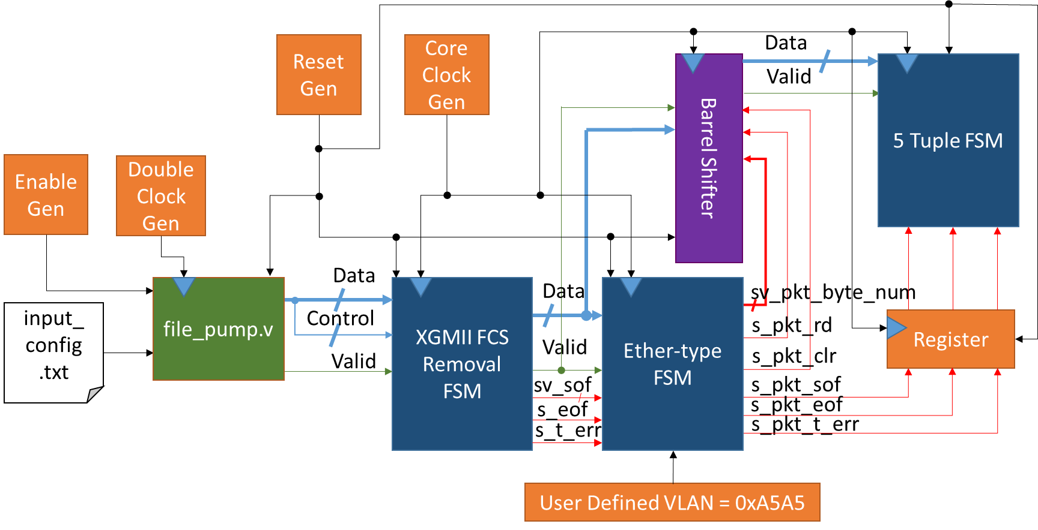

Figure 42: 5 Tuple FSM Test Bench Configuration

Figure 42 shows the test bench configuration that will be used to test the 5 Tuple FSM module. it can be seen that the start of frame, end of frame and propagated receiving traffic error signals are all register after exiting the Ether-type FSM. This will be done so as to align these signals with the data leaving the Barrel Shifter as there is a read delay of one clock cycle. The testing of this module must cover detecting the different IP protocol field values for ICMP, TCP and UDP which are 0x01, 0x06 and 0x11 respectively. This state machine must also detect errors in the internet header length field and also in the IP protocol field and the internet header field should only be decimal value 5 or 6 and the IP protocol field must match the previously stated values otherwise error signals will be set high.

|  |  |  |
| --- | --- | --- |
| ***Test Case*** | ***Description*** | ***Actions*** |
| 0 | Test the 5 Tuple extraction | * Three test frames, one for each protocol to de decoded, IP options not used * Three test frames, one for each protocol to de decoded, IP options used |
| 1 | Test the different types of receiving traffic errors that should be detected | * Four error test frames which will be; in the preamble of start of frame word , in the 32 bits after the start of frame word, on the end of frame word and in frame |
| 2 | Test that internet header length and protocol field errors are detected | * Two test frames to test each of the errors |

Table 8: 5 Tuple FSM Test Cases

As there is not an extensive amount of waveforms needed to be captured for the testing of this module all the waveform captures for test case 0 will be placed in Appendix C. Only three waveform captures will be examined in this report which will be the first two test frames of test case 0 to show the 5 Tuple being extracted properly, an overview of test case 1 to show how the state machine reacts to receiving traffic errors and an over of test case 2 to show the internet header length field error and the IP protocol field errors being detected. The inputted frames will only have the internet header length and IP protocol fields set in the IP header with the rest set to all zeros. The source and destination addresses will be set to 0xEAEAEAEA and0xECECECEC respectively with the source and destination port set to 0xAAAA and 0xCCCC respectively. These values should appear in the 5 Tuple after the extraction is completed.

**4.3.6.1. 5 Tuple FSM Waveform Analysis and Debugging Problems**

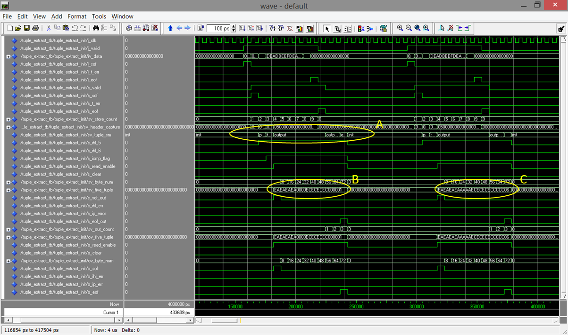

Figure 43: 5 Tuple FSM Test Case 0 test frames 1 and 2 Waveforms

Figure 43 shows the waveform capture of the first and second test frames of test case 0. As can be seen from the waveform highlighted by A the 5 Tuple FSM cycles through all states defined earlier in this document in section 3.5 showing correct functionality. It can be seen in the 5 Tuple signal highlighted by B that the source and destination port numbers are not added to the 5 Tuple as ICMP was detected to be used as the transport layer protocol as there is no port numbers used with the ICMP protocol and therefore can be verified to be correct. C shows that the port numbers are placed in the 5 Tuple extracted as TCP was detected to be in use as the transport layer protocol which is also correct functionality.

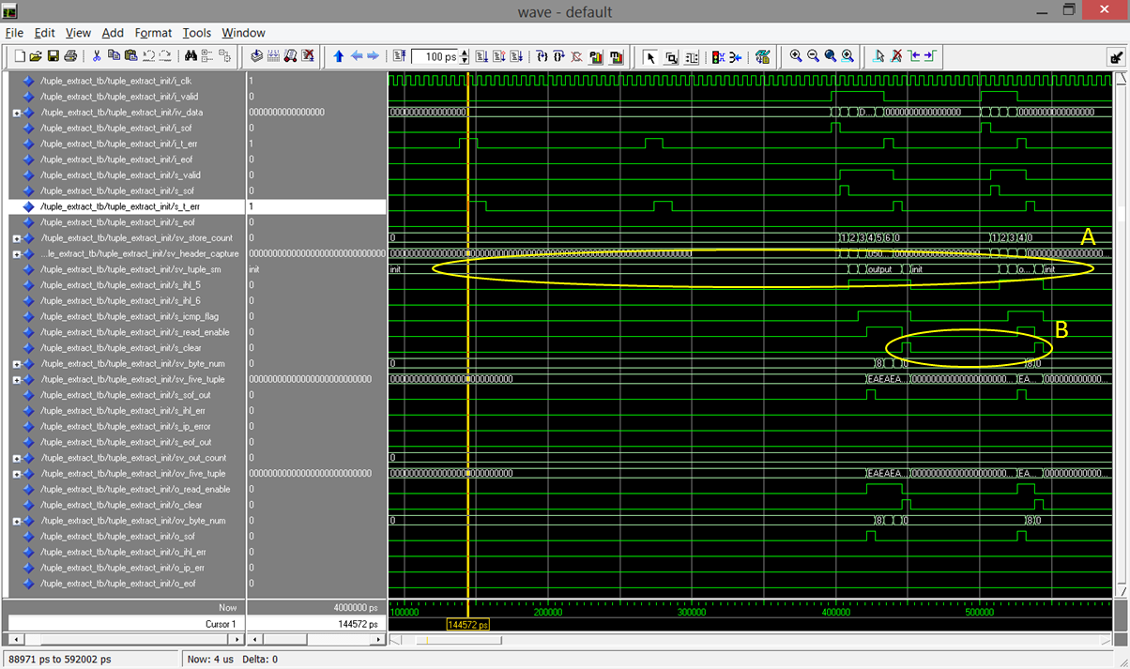

Figure 44: 5 Tuple FSM Test Case 1 Waveforms

The waveform capture for test case 1 of the 5 Tuple FSM module can be seen in figure 44. The highlight signal denoted by A shows the 5 Tuple FSM not moving from the INIT state for the first two test frames which have receiving traffic errors on the start of frame word which is correct functionality. This highlight signal also shows the state machine being cycled through for the test frames which have receiving traffic errors on the end of frame word and in frame which is also correct functionality as on both occasions the state machines are reinitialised after the errors are passed in. B shows that the Barrel Shifter used with the 5 Tuple FSM is cleared when a receiving traffic error is produced in frame or on the end of frame word.

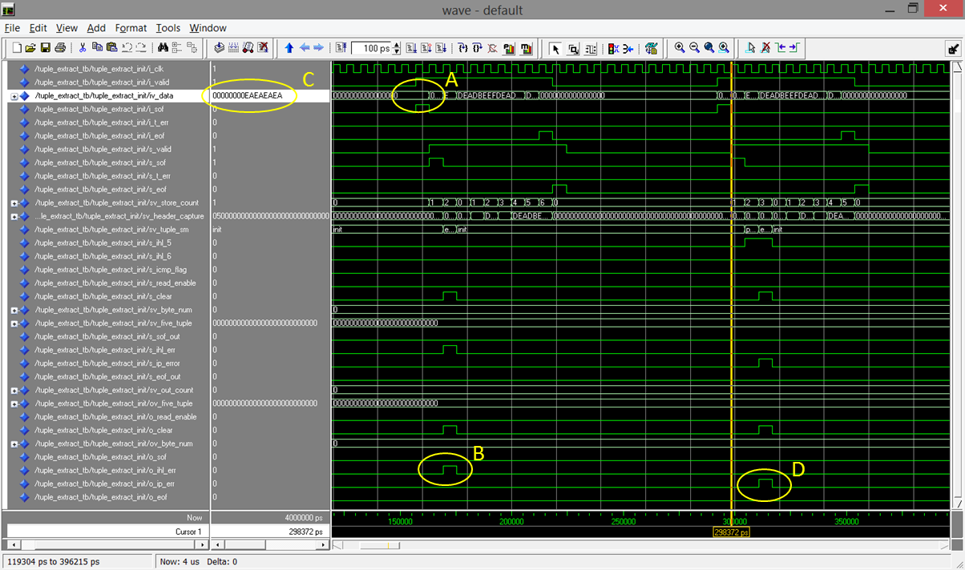

Figure 45: 5 Tuple FSM Test Case 2 Waveforms

Figure 45 shows the waveform capture of test case 2 that was ran on the 5 Tuple FSM module. A denoted the internet header length being inputted is equal to 0x00 and therefore will cause an error to be detected which can be seen to be going high by the signal that is highlighted by B. Similarly the IP protocol field can be seen to be inputted as 0x00 by the highlighted value of C which also sets its corresponding error signal high which is denoted by D. This test case has shown that the errors that are to be detected are correctly flagged and therefore verifying the functionality of this state machine.

The only problems that affected the implementation of this module was correctly finding the positions to extract the 5 Tuple which was easily solved using a spreadsheet and making sure that no matter what state the FSM was in, if a receiving traffic error was detected the state machine would reinitialise.

**4.4 Top Level Verification**

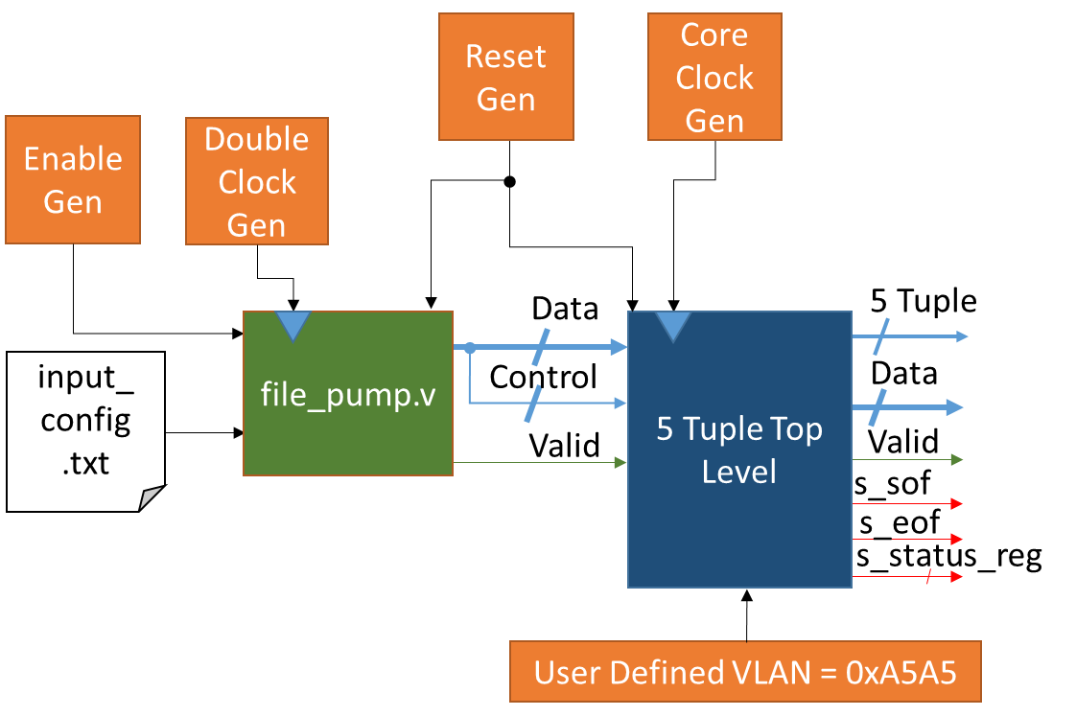

Figure 46: 5 Tuple Top Level Test Bench Configuration

Above shows the test bench configuration of the 5 Tuple Top Level module. In comparison to the top level entity declaration stated in section 4.2 it can be seen that all I/O are assigned in figure 46. All sub modules of this module have been extensively tested and therefore there is no necessity to complete all of the previous test cases on the top level module but test to examine the functionality of the 5 Tuple Top Level module are required. The test cases that will be ran on the top level are stated in Table 9. Part of the data that is inputted to this module is used as the XGMII control as it is concatenated together in the input test file.

|  |  |  |
| --- | --- | --- |
| ***Test Case*** | ***Description*** | ***Actions*** |
| 0 | Test basic functionality | * Reuse test case 0 of the Ether-type verification (see section 4.3.4) |
| 1 | Test the different types of receiving traffic errors that should be detected | * Four error test frames which will be; in the preamble of start of frame word , in the 32 bits after the start of frame word, on the end of frame word and in frame |
| 2 | Test that internet header length and protocol field errors are detected | * Two test frames to test each of the errors |
| 3 | Test the Ether-type error and MPLS error detection in each state | * Reused test case 7 of the Ether-type verification (see section 4.3.4) |

Table 9: 5 Tuple Top Level Test Cases

As all of these tests have been ran before none of the waveform captures will be added to the Appendix. The waveforms that will be assessed will be an example test frame from test case 1 to show proper functionality of the module, an overview of the receiving traffic errors, an overview of the Ether-type and MPLS errors and also an overview of the internet header length and IP protocol errors so as to study how the status register is set depending on the error detected.

**4.4.1. 5 Tuple Top Level Waveform Analysis and Debugging Problems**

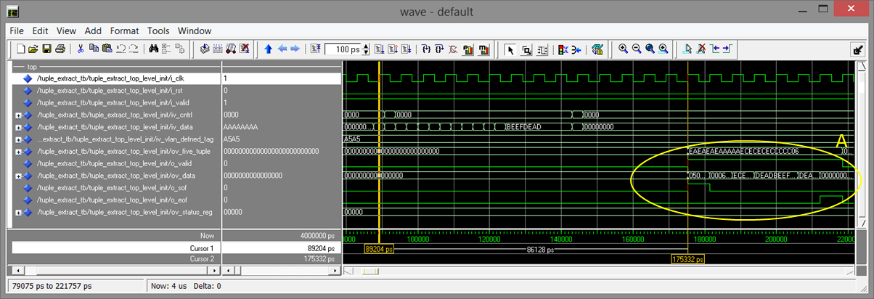

Figure 47: 5 Tuple Top Level Test Case 0 test frame 1 Waveforms

The waveform capture above shows the resulting waveforms of the I/O of the 5 Tuple top Level module for the first test frame in test case 0. This test frame is a simple IP frame so as to show the quickest performance of the module. It can be seen that it takes 86128 picoseconds (ps) between the first cursor and the second which accounts for a total of 14 clock cycles before the 5 Tuple and packet are passed out. The highlighted signals denoted by A show the output signals of the top level module which show correct functionality verifying the normal operation of the state machine.

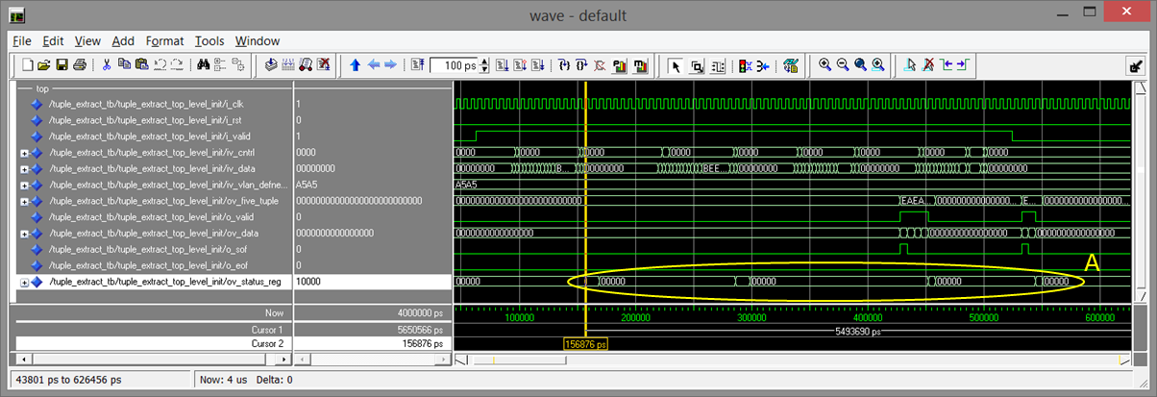

Figure 48: 5 Tuple Top Level Test Case 1 Waveforms

Figure 48 shows the test case waveform capture of test case 1 to verify the 5 Tuple Top Level. The receiving traffic errors that are logged into the status register are denoted by A and can be seen to be set to the expected binary value of 10000. The status register can be seen to be set after the 5 Tuple, data and valid out are all set to zeros which is correct functionality can therefore this module is verified for the use of receiving traffic errors.

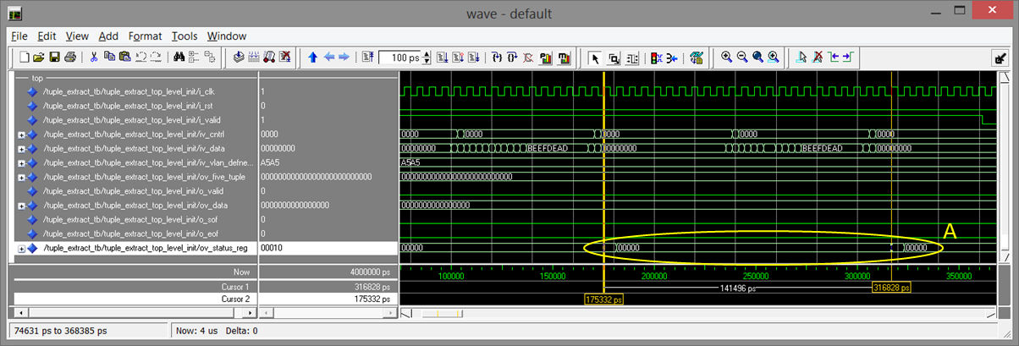

Figure 49: 5 Tuple Top Level Test Case 2 Waveforms

Above shows the waveform capture of the test case 2 ran on the 5 Tuple Top Level module. A denotes the status register being set to binary values 00010 and 00001 which are to indicate if an internet header length error or an IP protocol error have been detected. This shows correct functionality verifying that the design handles these types of errors properly.

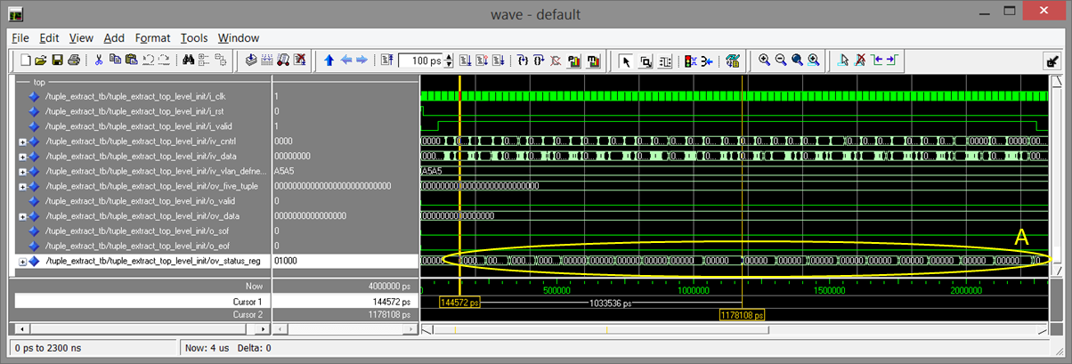

Figure 50: 5 Tuple Top Level Test Case 3 Waveforms

Figure 50 shows the waveform capture for 5 Tuple Top Level module after test case 3 was ran. A denotes the status register being set to binary values 01000 and 00100 which are to indicate if an Ether-type error or a MPLS error have been detected. This shows correct functionality verifying that the design handles these types of errors properly.

There was an error found while testing the top level which was that the status register set the receiving traffic error signal out of the module before the data was cleared in the Barrel Shifters and the state machines were reinitialised. This was easily fixed by outputting the propagated error signal that is passed to the 5 Tuple FSM from this module and registering it into the status register.

All the code is now verified and can be found in Appendix D.

**5. Circuit Analysis and Optimisation**

In this section of the report the design of the 5 Tuple extraction module, that is defined in section 3 and verified in section 4, will be synthesised and implemented using Xilinx’s Vivado software. Synthesis is the process of converting the hardware description language into logic and the implementation is the procedure of placing and routing the logic on to the FPGA. By doing the synthesis and implementation an area utilization report and timing report can be produced which will be used to analyse the design and to determine any optimisations that could be carried out. These optimisations will hopefully reduce the amount of Lookup Tables (LUTs) and register slices utilized by the design.

Firstly the design already produced must be synthesised and the utilization will be record. Then the implementation will be processed and the utilization will be compared to the synthesis. If the design does not meet timing then solutions must be carried out to make the design functional. After the design has been altered to meet timing, an optimisation can be produced to reduce the LUT and register slice count. This optimisation will then be compared to the first design to quantify the magnitude of the improvements made.

For this report the FPGA provided is actually an All Programmable System on a Chip (AP SoC) Zynq-7010 (xc7z010clg400-1) which is implemented on a ZYBO [43] evaluation board that are produced by Digilent. The Zynq AP SoC [44] makes use of an ARM® dual-core Cortex™-A9 MPCore processor and one of Xilinx’s 7 series FPGAs. For the ZYBO board the FPGA component will be an Artix 7 with the lowest specification. This board can be purchased with a Vivado licence which covers all Zynq chip so if the board provided cannot fit the design on to the FPGA part of the chip another Zynq can be chosen to review the design. The specification for the Zynq-7010 can be found in Table 10.

|  |  |
| --- | --- |
| ***I/O Pin Count*** | 400 |
| ***Available IOBs*** | 100 |
| ***LUT Elements*** | 17600 |
| ***FlipFlops*** | 35200 |
| ***Block RAMs*** | 60 |
| ***DSPs*** | 80 |

Table 10: Zynq-7010 Specification

**5.1 FPGA Requirements**

For this design the synthesis was ran using the ZYBO board configuration which was found to be too small for the design to fit on to the FPGA of the Zynq-7010. The summary graph of the synthesis can be found on Figure 51 and the utilization report can be found in Table 11.

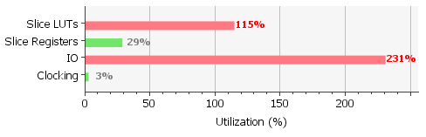

Figure 51: Zynq-7010 Synthesis Summary Graph

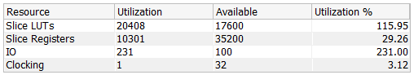

Table 11: Zynq-7010 Synthesis Utilization Report

As can be seen from Figure 51 and Table 11 that the chosen Zynq AP SoC doesn’t meet the requirements for this design therefore a more adequate device must be used. From reviewing the design requirements the majoring factor in the decision for the correct Zynq chip is the available IOBs. The Zynq-7010 only provide 100 IOBs which is far too small an amount as the total IOBs count for the design is 231 therefore the Zynq-7030 (xc7z030fbg676-1) will be used to synthesis and implement the design. The LUT count for this design on the Zynq-7010 is 20408 which is also a reason why this chip cannot be used as it only provide 17600 LUTs. The Zynq-7030 that will be used has the specification stated in Table 12.

|  |  |
| --- | --- |
| ***I/O Pin Count*** | 676 |
| ***Available IOBs*** | 250 |
| ***LUT Elements*** | 78600 |
| ***FlipFlops*** | 157200 |
| ***Block RAMs*** | 265 |
| ***DSPs*** | 400 |

Table 12: Zynq-7030 Specification

**5.2 Design Synthesis and Implementation**

In this section of this report the design for the 5 Tuple extraction module that is specified and verified in this document will be passed through both the synthesis and implementation stages of Xilinx’s Vivado. This is to be done so as to determine the utilization of the circuit and to correct any timing problems of the design.

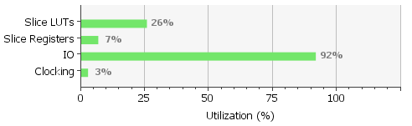

Figure 52: Zynq-7030 Synthesis Summary Graph

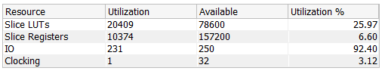

Table 13: Zynq-7030 Synthesis Utilization Report

Figure 52 shows the utilization of the design in terms of the percentage of the device that is used. It can be seen that the amount of IOBs (referred to as IO in the graph and table) this device is adequate for the design as all other utilizations are well below full usage. This is also evident in Table 13.

**5.2.1 Synthesis and Implementation Problems and Solutions**

There were a number of problems that arouse while attempting to synthesis and implement the design which only appeared in the Double Data Rate Converter. The errors that had to be corrected first was that the rising edge and falling edge registered processes were combined which was not a problem in simulation but is not synthesisable so to correct this the rising edge and falling edge registered processes were placed in their own separate process. Then the design was passed through the synthesis again this error was removed and the design could synthesise correctly.

The second problem that affected the design was that there was the use of a falling edge registered process which Vivado had difficulty deciphering. This was easily fixed by changing the falling edge process to a rising edge process and NOTing the input clock to the process

The third problem that arouse was when the design was being passed through the implementation which places and routes the logic previously synthesised. This process takes into account the timing of the design and calculates the slack of the signals. If there is a route that has too much combinational logic or is just too long a route the implementation crashes. This happened to the register reset in the Double Data Rate Converter for the falling edge capture of the data which was also very easily solved by re-registering the reset signal before it was passed to the falling edge registered process.

The corrected version of the Double Data Rate Converter VHDL code can be found in Appendix E. Figure 53 shows the device view of the design after it is implemented on to the FPGA.

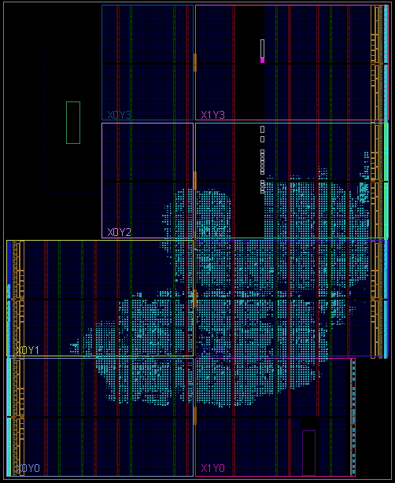

Figure 53: Original Design Zynq-7030 Device View

**5.2.2 Original Architecture Circuit Analysis**

In this section of the report the original design will have the constraints of the clock adjusted so as to determine how well the architecture preforms at higher clock speeds. The clock will be gradually increased so as to determine what clock frequency will cause the design to not meet the timing requirements. The clock frequencies that are used to test the design are in Table 14 as well as if the test passed of failed and the LUT count.

|  |  |  |
| --- | --- | --- |
| ***Clock Frequency (MHz)*** | ***Pass or Fail*** | ***LUT Count*** |
| 156.25 | PASS | 20409 |
| 170 | PASS | 20411 |
| 180 | PASS | 20411 |
| 190 | PASS | 20434 |
| 200 | FAIL | 20475 |

Table 14: Original Design Timing Testing

The best clock frequency that the architecture can work at is 190 MHz as when Vivado attempted to perform the implementation procedure the time failed. The reason that design failed is that the input data to the Double Data Rate Converter had negative slack. The reason for this was that the route that was trying to be produced had too much of a delay as the route contributed 89.8341% of the delay time which was indicated in the timing report. The LUT count can be seen to be increasing, this is due to more logic being needed to deal with a faster clock.

**5.3. Area Utilization Optimisation**

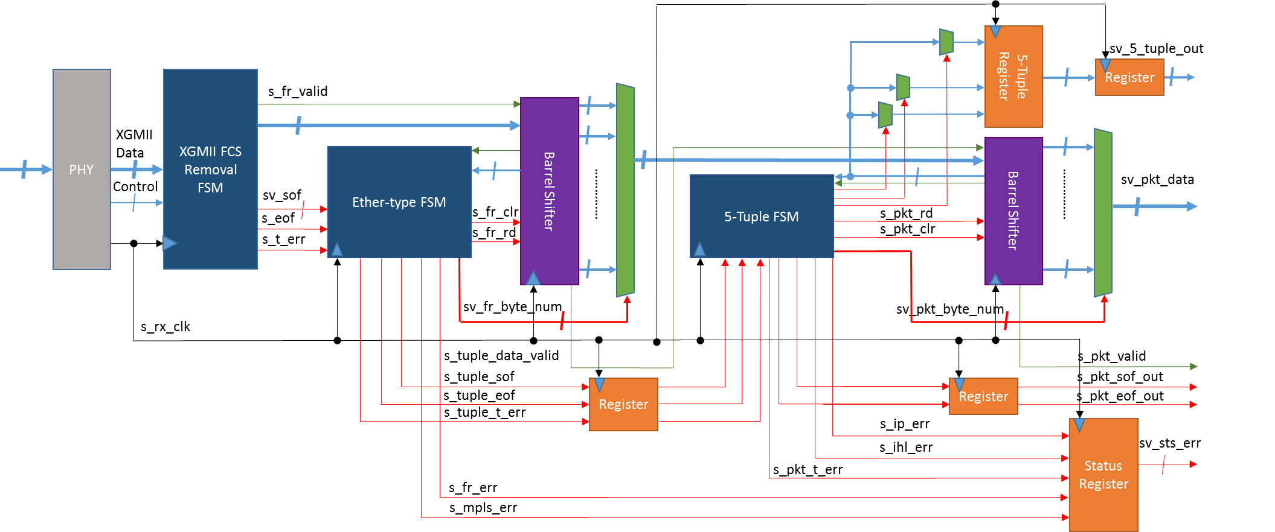

Figure 54: Area Utilization Optimisation Architecture

The proposed architecture for an area utilization optimisation of the 5 Tuple design original produced for the report can be seen in Figure 54. This architecture has the header store registers from the original design removed and the Barrel Shifter is used to inspect the Ethernet frame and to extract the 5 Tuple. This will theoretically reduce the LUT count and register slices used by the design.

**5.3.1 Area Utilization Optimisation Synthesis and Implementation**

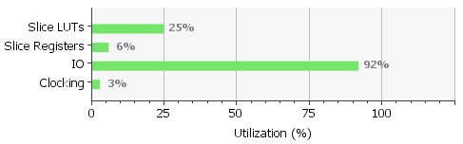

Figure 55: Optimisation Synthesis Summary Graph

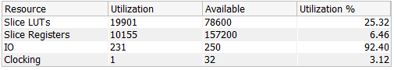

Table 15: Optimisation Synthesis Utilization Report

This section will cover the utilization report and timing report for the optimised design. Figure 55 and Table 15 shows the utilization of the design in terms of the percentage of the device that is used in comparison to what is available on the FPGA.

The LUT count has been reduced by 508 and the register slices have been reduced by 219. This is a good improvement on the original design although it is possible to further optimise the design by combining the Ether-type FSM and the 5 Tuple FSM. This would reduce the design to only one Barrel Shifter which uses a large about of LUTs to perform the MUXing, therefore it would have a bigger reduction to the design. The code for this optimisation for the new top level, the new Ether-type FSM and the new 5 Tuple FSM can be found in Appendix F.

**6. Project Plan**



Figure 56: Project Gantt Chart

Figure 56 outlines the final year project plan, developed and agreed soon after the background research in January 2015. The requirements and feasibility and the interim task was to find an FPGA that was thought to be adequate for the design and to produce the interim report which contained the research done for this report and a first draft system architecture.

The design task of the project was to design the hierarchy of the design and to produce individual designs for each of the sub modules defined in the top level module.

The coding and debugging task was to take the designs previously produced and convert them into hardware discretion language and test that the code compiled.

The verification task was to take the code that was found to compile and place it into a test bench so that the code could be simulated and run a number of test cases to determine that the design worked correctly and that it didn’t get stuck in any of the states in the state machines.

the circuit analysis and optimise task was to take the design that was fully verified and put it through a synthesis tool at different clock frequencies to find the maximum clock rate that could be achieved and to determine the utilization of the FPGA. As well as this the design was optimised to reduce the area utilization.

The documentation task was to complete this report as the different tasks were completed.

In relation to the project plan produced for this report not everything went as specified. The first draft hierarchical design was done in a fashion that would require a lot more work than needed so it was redesigned which causes a setback in the design task which in turn causes a setback the every task that was to be completed after the design task. The first draft design had divided up the functionality of the Ether-type FSM and the 5 Tuple FSM so these functionalities were grouped together to reduce the complexity of the design. This caused the coding and debugging task to be finished on the 14th week between the 20th and 26th of April which in turn caused the verification task to be finished on the same week.

After these tasks were completed the research that was previously produced for the interim report was reviewed and corrected and more sections and references were added. Then the design section of the report was reproduced with an extension to the information already stated. Then the verification section had to be added to fully explain how the design was verified. These tasks unexpectedly took up a lot of time and caused the optimisation to be pushed back until the last week between the 11th and 15th of May. During the final week this report was finalised and reviewed.

**7. Conclusions and Future Work**

The objective of this report was to design, code, debug, verify and optimise a 5 Tuple extraction circuit for 10 Gb/s data rate that was to be produced for a FPGA that was manufactured by Xilinx. The design was to be produced using the hardware description language VHDL and coded, debugged and verified with the use of Mentor Graphics ModelSim with the test benches produced in the hardware description language Verilog. Vivado was to be used to preform circuit analysis on the verified design.

There was research done on the OSI model, the Physical layer and XGMII, the Ethernet frame format, VLAN tagging, MPLS, IP header format, ICMP header format, TCP header format, UDP header format, traffic classification, traffic normalisation, hardware design process, Ethernet frame formats with VLAN and MPLS and then Endianness of the traffic. After the research was completed an extensive design was produced covering all functionality that was required of the design. Using this design the 5 Tuple extraction module was coded and debugged. When the code was finalised the design was then verified with a number of different test bench configurations and test cases so as to test each sub module individually and as well as a top level test bench and test cases to verify the design as a completed module. Any problems that were found during the verification stage were fixed with ease. The verified design was then passed through a synthesis tool to determine the utilization of the Zynq-7030 AP SoC. This device was chosen as the device that was provided could not fit the design on to it. The design was also tested to find the maximum functional clock frequency. The original system architecture was then optimised so as to reduce the LUT and register count which was found to reduce both by 508 LUTs and 219 registers.

Most of the objective have been met in this report expect for optimising the design for performance and implementing the design on to a physical FPGA. The design was not optimised for performance as there was not enough time to produce both area utilization optimisation and throughput optimisation. This is also the case for why the design was not built on to a physical FPGA. Aside from these all other objectives have been covered with unambiguous detail as the Background Research, System Architecture and Verification sections of this report have covered all relevant material extensively. The main challenges of this project have been the meticulous verification process and the correcting of the Double Data Rate Converter module so that it was synthesisable and implementable. The solution to correct the Double Data Rate Converter was an educational task which was done with ease. Additionally there was a problem with the device that was to be used for this project which had to be reassessed to find the optimal device for the design.

Future work that could be done for this project would be to further optimise the design so as to further reduce the LUT and register count and increase the throughput of the system. This can be done by incorporating the 5 Tuple FSM into the Ether-type FSM which would reduce the number of Barrel Shifter modules used in the architecture and increase the throughput. The throughput would be increased as there would be a reduced number of clock cycles taken between a frame entering the system and the 5 Tuple and IP packet being outputted from the system by reducing the number of total states of FSMs in the design. By reducing the number of Barrel Shifters used in the design the area utilization of the design would be greatly improved. Other than a further optimisation the design could be scaled to a 40 Gb/s data rate. It was previously mentioned in the Clock Rate Calculation section of this report that if the data width was maintained as 64 bit for a 40 Gb/s design the clock frequency required would be 625 MHz. This clock frequency is too large to be implemented so the data width has to be 256 bits and therefore the clock frequency is maintained at 156.25 MHz. this would mean that more data would be passed into the design in a single clock cycle so therefore more data can be decoded in a single clock cycle. This would be good but could cause critical path problems due to too much information being decoded. This problem would be due to a large combinational logic block between two register that causes too much of a delay so that the signals to be produced are not set up in time for the next rising edge of the digital clock.

**References**

[1] Techopedia, “5-Tuple”, Available:

[http://www.techopedia.com/definition/28190/5-Tuple](http://www.techopedia.com/definition/28190/5-tuple)

[2] Wikipedia “Ethernet”, Available:

http://en.wikipedia.org/wiki/Ethernet

[3] ISO, “Open Systems Interconnection Model”. Available: http://www.iso.org/iso/home/store/catalogue_tc/catalogue_detail.htm?csnumber=20269

[4] IEEE 802.3, “IEEE Standard for Ethernet”, Available: http://standards.ieee.org/about/get/802/802.3.html?utm_source=Mainsite_CSE&utm_medium=CSE_Promotion&utm_term=802.3&utm_campaign=Standards_Promotion-mac

[5] Wikipedia, “Local Area Network”, Available:

http://en.wikipedia.org/wiki/Local_area_network

[6] IEEE 802.1Q, “Virtual Bridged Local Area Networks”, Available:

http://www.ieee802.org/1/pages/802.1Q-rev.html

[7] RFC 3031, “Multiprotocol Label Switching Architecture”, Available:

<http://tools.ietf.org/html/rfc3031>

[8] RFC 791, “Internet Protocol”, Available:

http://tools.ietf.org/html/rfc791

[0] RFC 792, “Internet Control Message Protocol” Available:

<https://tools.ietf.org/html/rfc792>

[10] RFC 793, “Transmission Control Protocol”, Available:

<https://www.ietf.org/rfc/rfc793.txt>

[11] RFC 768, "User Datagram Protocol", Available:

<https://www.ietf.org/rfc/rfc768.txt>

[12] Wikipedia, "Field Programmable Gate Array", Available:

http://en.wikipedia.org/wiki/Field-programmable_gate_array

[13] Wikipedia, “Application Specific Integrated Circuit”. Available: http://en.wikipedia.org/wiki/Application-specific_integrated_circuit

[14] Mentor, “ModelSim”, Available:

http://www.mentor.com/products/fv/modelsim/

[15] Xilinx, “Vivado”. Available:

http://www.xilinx.com/products/design-tools/vivado.html

[16] Windows Networking, “OSI Reference Model: Layer 1 hardware”, Available:

http://www.windowsnetworking.com/articles-tutorials/common/OSI-Reference-Model-Layer1-hardware.html

[17] Wikipedia, “Application programming interface”. Available:

http://en.wikipedia.org/wiki/Application_programming_interface

[18] Wikipedia, “64b/66b Encoding”, Available:

http://en.wikipedia.org/wiki/64b/66b_encoding

[19] Wikipedia, “DC Bias”. Available:

<http://en.wikipedia.org/wiki/DC_bias>

[20] Wikipedia, “Double Data Rate”, Available:

http://en.wikipedia.org/wiki/Double_data_rate

[21] GL Communication Inc, “Optical and Ethernet Testing”, Available:

http://www.gl.com/optical-and-ethernet-testing-packetexpert.html

[22] Wikipedia, “Cyclic Redundancy Check”, Available: <http://en.wikipedia.org/wiki/Cyclic_redundancy_check>

[23] Wikipedia, “Ether-type”, Available:

http://en.wikipedia.org/wiki/EtherType

[24] IETF, “Media Access Control Bridges and Virtual Bridged Local Area Networks”. Available:

www.ietf.org/meeting/86/tutorials/86-ieee-8021-thaler.pptx

[25] NetworkStatic, “Putting Together Provider Bridging and Provider Backbone Bridging S-Tags and C-Tags”. Available:

http://networkstatic.net/putting-together-provider-bridging-provider-backbone-bridging-s-tags-and-c-tags/

[26] Wikipedia, “Forwarding Information Base”, Available: http://en.wikipedia.org/wiki/Forwarding_information_base

[27] Juniper, “Configuring the Maximum Number of MPLS Labels”, Available: http://www.juniper.net/documentation/en_US/junos14.1/topics/task/configuration/interfaces-mpls-maximum-labels.html

[28] Global Knowledge, “MPLS - Part 10”, Available:

http://blog.globalknowledge.com/technology/cisco/routing-switching/mpls-%E2%80%93-part-10/#

[29] NMAP, “TCP/IP Reference”. Available:

http://nmap.org/book/tcpip-ref.html

[30] IETF, “Internet Protocol, Version 6 (IPv6)”, Available:

https://www.ietf.org/rfc/rfc2460.txt

[31] BogPeople, “IP Precedence, TOS & Diffserv”, Available:

http://bogpeople.com/networking/dscp.shtml

[32] Wikipedia, “Interior Gateway Protocol”. Available: <http://en.wikipedia.org/wiki/Interior_gateway_protocol>

[33] Wikipedia, “Exterior Gateway Protocol”. Available: <http://en.wikipedia.org/wiki/Exterior_gateway_protocol>

[34] The TCP/IP Guide, “TCP Connection Establishment Process: The "Three-Way Handshake"”, Available:

http://www.tcpipguide.com/free/t_TCPConnectionEstablishmentProcessTheThreeWayHandsh-3.htm

[35] Wikipedia, “Voice over IP”, Available:

http://en.wikipedia.org/wiki/Voice_over_IP

[36] Wikipedia, “Denial-of-Service Attack”, Available:

http://en.wikipedia.org/wiki/Denial-of-service_attack

[37] RFC 2475, “Architecture for Differential Services”, Available:

http://tools.ietf.org/html/rfc2475

[38] Data Network Resource, “Quality of Service” Available:

http://www.rhyshaden.com/qos.htm

[39] Wikipedia, “Firewall (computing)”, Available:

http://en.wikipedia.org/wiki/Firewall_(computing)

[40] Mark Handley, Vern Paxson and Christian Kreibich, “Network Intrusion Detection: Evasion,Traffic Normalization, and End-to-End Protocol Semantics”, Available:

<http://ranger.uta.edu/~dliu/courses/cse6392-ids-spring2007/papers/USENIXSec2001-NIDEvasion.pdf>

[41] Wikipedia, “Flip Flop”, Available:

http://en.wikipedia.org/wiki/Flip-flop_%28electronics%29#D_flip-flop

[42] TcL Developer Xchange, Available:

http://www.tcl.tk/

[43] Digilent, “ZYBO Zynq™-7000 Development Board”, Available:

https://www.digilentinc.com/Products/Detail.cfm?Prod=ZYBO

[44] Xilinx, “Zynq-7000 All Programmable SoC”, Available:

http://www.xilinx.com/products/silicon-devices/soc/zynq-7000.html